**DEVELOPMENT OF LMS: LIBRARY MANAGEMENT SYSTEM OF ERHARD SYSTEMS TECHNOLOGICAL INSTITUTE**

**A Thesis**

Presented to

The Faculty of The

Computer Science Department

Erhard Systems Technological Institute

Odiongan, Romblon

In Partial Fulfillment

of the Requirements for the Degree

Bachelor of Science in Computer Science

By:

CEDRIC JOHN LUSTRIA CAWALING

June 2025

**APPROVAL SHEET**

The study entitled “Development of LMS: Library Management System of Erhard Systems Technological Institute”, prepared and submitted Cedric John Lustria Cawaling in partial fulfillment of the requirements for the degree Bachelor of Science in Computer Science, has been examined and is recommended for acceptance and approval for ORAL EXAMINATION.

Avegail L. Manggol, MIT, LPT

Adviser

**PANEL OF EXAMINERS**

Approved by the committee on oral examination with a grade of ________.

______________________

Chairman

______________________ ______________________

Member Member

Accepted and approved in partial fulfillment of the requirements for the degree **BACHELOR OF SCIENCE IN COMPUTER SCIENCE.**

_____________________ Dr. Idella G. Formilleza

Date Signed President

**DEDICATION**

The researcher sincerely dedicates this thesis to all the people who offered their support, encouragement, and guidance throughout the completion of this work.

To the Almighty God, thank You for granting us the strength, wisdom, and patience to carry this through.

To our beloved alma mater, ESTI, for being the foundation of our learning and growth.

To our teachers, thank you for sharing your knowledge and for your unwavering support.

To our families, whose love and sacrifices inspired us to keep going even during difficult times.

To our friends, classmates, and fellow students—your encouragement, laughter, and presence made this journey lighter and more meaningful.

**C.J.L.C**

**ACKNOWLEDGEMENT**

I would like to express my sincerest gratitude to my adviser, Ms. Avegail L. Manggol, for her constant support, valuable guidance, and constructive feedback throughout the course of this research. Her encouragement and expertise have been instrumental in shaping this study.

To the respondents of this research, thank you for your time and willingness to participate by thoughtfully answering the questionnaires. Your cooperation made this work possible.

I am deeply thankful to my family and friends for their patience, encouragement, and unwavering support during every step of this journey.

Lastly, I would like to recognize and extend my appreciation to the researchers and authors whose studies provided a strong foundation and direction for this work.

**ABSTRACT**

**TITLE :** Development of LMS: Library Management System of Erhard Systems Technological Institute

**RESEARCHER :** Cedric John Lustria Cawaling

**ADVISER :**  Avegail L. Manggol

**COURSE :** Bachelor of Science in Computer Science

**SCHOOL YEAR :** 2024-2025

**SUMMARY :**

This study aimed to design and develop a Library Management System (LMS) for Erhard Systems Technological Institute (ESTI) to automate and streamline library operations. The system was developed as a desktop application using VB.NET and Microsoft SQL Server, incorporating essential modules such as user authentication with one-time password (OTP), book management, borrowing and returning transactions, online public access catalog (OPAC), visitor logging, report generation, and overdue notifications.

The system's objective was to replace manual processes with a more efficient and accurate solution that enhances library management. A total of thirty (30) respondents—composed of twenty (20) students and ten (10) ESTI employees—evaluated the system using a standardized Likert-scale instrument based on the FURPS model, which includes Functionality, Usability, Reliability, Performance, and Supportability.

Results revealed that the system achieved an overall mean score of 4.16, interpreted as Strongly Agree. Among the five criteria, Supportability received the highest rating with a mean of 4.36, followed by Performance (4.20), Reliability (4.13), Functionality (4.20), and Usability (4.00). These results confirm that the developed LMS met its intended objectives and was perceived as effective, user-friendly, and reliable.

The study concludes that the implementation of a customized LMS can significantly improve library efficiency and accuracy, and it recommends further enhancements such as a web-based version and automated backup integration.

**TABLE OF CONTENTS**

**PRELIMINARIES Page**

Title Page i

Approval Sheet ii

Dedication iii

Acknowledgement iv

Abstract v

Table of Contents vi

List of Figures viii

List of Tables xi

**Chapter 1: INTRODUCTION**

Background of the Study 1

Objectives of the Study 3

Significance of the Study 5

Scope and Limitations of the Study 6

Assumptions of the Study 7

**Chapter 2: REVIEW OF RELATED LITERATURE**

Related Literature 8

Related Studies 27

Conceptual Framework of the Study 33

Operational Definition of Terms 35

**Chapter 3: METHODOLOGY**

Project Design 36  
Project Development 41  
Operation and Testing Procedures 45

**LIST OF FIGURES**

**Figure No. Title Page**

1.0 Physical Log Entry/ Log Register Book 9

2.0 Key Features of Library Systems 9

3.0 CHED Logo 10

4.0 Accession Book Record 13

5.0 Card Catalog 14

6.0 Logo mark of Visual Studio 2022 15

7.0 Logo mark of Visual Basic .Net 16

8.0 The logo of Windows 10 16

9.0 Screenshot of Visual Studio’s Windows Forms 18

10.0 Figma Logo 19

11.0 The Uno Platform open-source project logo 19

12.0 Adobe PDF icon 20

13.0 Laptop 21

14.0 Erhard Systems Technological Institute 24

15.0 iSlim LMS User interface 27

16.0 Koha Integrated Library System 28

17.0 Koha User Interface 29

18.0 CodeAchi User Interface 29

19.0 UP Integrated Library System (iLib) 30

20.0 The Conceptual Framework of the Study 33

21.0 LMS User Interface – Homepage 36

22.0 Data Flow Diagram of the LMS 38

23.0 Hierarchy Input-Output (HIPO) Diagram 39

24.0 Software Development Life Cycle (SDLC) 41

25.0 Load Screen 54

26.0 Admin Registration Screen 55

27.0 Main Dashboard 56

28.0 Add Book Process Flow 57

29.0 Choose Photo Feature 58

30.0 Accession Record Table 59

31.0 Edit Book Screen 60

32.0 Filter and Search Books 61

33.0 Quick Access Library Access Record 62

34.0 Login Page Library Access Record 62

35.0 Library Log Entries Screen 63

36.0 Log History 64

37.0 Save As Dialog for Logs 65

38.0 OPAC Screen 66

39.0 Book Details Interface 67

40.0 Transactions Module 68

41.0 Transaction Details Popup 69

42.0 Save File Dialog for Transactions 70

43.0 Profile Management Panel 71

44.0 Change Password with 2FA and Google Authenticator 71

45.0 Change Password Confirmation 72

46.0 Choose Admin Profile Photo 73

47.0 Update Admin Details 73

48.0 Add Admin Accounts 74

49.0 Edit/Delete Admin Account 75

50.0 Notifications Panel 76

51.0 Statistics Panel 77

52.0 Statistics Panel – Generate Book Report 77

53.0 Logout Button 78

54.0 Login/Log Entry Form 78

55.0 About Panel with School History 79

**LIST OF TABLES**

**Table No. Title Page**

CHAPTER 1

**INTRODUCTION**

This chapter includes the background of the study, objectives of the study, significance of the study, scope and limitations of the study and assumption of the study.

**Background of the Study**

Libraries serve as vital repositories of knowledge, playing a crucial role in supporting learning, research, and community engagement. However, the traditional manual processes involved in library management often lead to inefficiencies, errors, and challenges in meeting the evolving needs of users. As technology advances and user expectations change, there is a growing demand for modern solutions to streamline library operations and enhance services.

Implementing a library system in school libraries significantly enhances efficiency and accessibility. It simplifies cataloging and circulation, making it easier for students and staff to locate and borrow resources. Automated inventory management reduces errors and saves time, allowing librarians to focus on user support and educational activities.

The library management system currently used by the librarian at ESTI is a downloadable software accessible through Google, offering essential functionalities for effective library management. These include exploring and viewing book details, recording book issuance and returns, updating book records, and managing the library's collection and members. However, the system also includes unused features such as membership packages and ID numbers, which do not align with the specific operational needs of the ESTI library, leaving these functionalities dormant and unintegrated into daily operations.

Similarly, ESTI’s School Management System (SMS) includes a library management feature that is convenient for basic tasks and can generate reports, though these reports are limited in detail. While it offers essential features for managing a school library, it remains underdeveloped and does not fully meet the library's specific needs. It is primarily used as a book inventory system. This incomplete functionality results in a system that falls short of supporting the comprehensive management required for an effective school library.

The development of a Library Management System (LMS) for Erhard Systems Technological Institute (ESTI) aims to optimize the librarian's work by automating essential library functions. This system will reduce the reliance on manual processes such as written forms, accession records, and receipts. It will also eliminate the use of third-party software, enhancing data security against threats like hacking and viruses. The LMS will be tailored to include only the features relevant to managing the ESTI library, aligning closely with typical library management systems while addressing the institution's specific needs.

**Objectives of the Study**

The general objective of this study is to develop a Library Management System (LMS) for Erhard Systems Technological Institute (ESTI) that will digitize and streamline the management of books, borrower records, and overall library operations.

To achieve this objective, the following specific goals were pursued:

1. **To design a system with the following features:**

a. A **login form** that restricts access to authorized admin users only, enforces password changes for default credentials, and supports OTP-based two-factor authentication;

b. A **log entry module** to record all visitor activity, capturing name, role, and purpose of visit, while preventing duplicate borrowing or return logs on the same day;

c. Support for adding, editing, deleting, and filtering books, including thumbnail storage and auto-generated Book IDs;

d. **Borrowing and return modules** that track due dates and return statuses, with logic to flag overdue items;

e. An **OPAC module** to allow users to search and view books by title, author, or material type;

f. **Alerts** on overdue books based on borrowing transactions;

g. **Statistics module** that provides graphs and summaries such as the number of books borrowed, returned, overdue, and total log entries;

h. **Profile management** functionality that allows administrators to view and update their account details and securely change passwords;

i. **Role-based access** for administrators with customizable permissions.

1. **To create the system as designed using the following tools:**  
   **Software:**  
   a. Visual Studio (VB.NET)  
   b. Microsoft SQL Server (with TableAdapters)  
   c. Microsoft Windows 10 operating system or higher  
   d. iTextSharp PDF library  
   e. QRCoder and Otp.NET libraries  
   f. SQL Server Management Studio (SSMS)

**Hardware:**  
a. Laptop  
b. Intel(R) Core(TM) i3-4005U CPU @ 1.70GHz  
c. 8.00 GB RAM  
d. 64-bit operating system, x64-based processor

1. **To test and improve** the developed library system.
2. **To evaluate** the overall performance of the system using the FURPS model for testing software quality.

**Significance of the Study**

The ESTI Library Management System is important for modernizing and improving the management of school libraries. Specifically, the system simplifies the librarian’s workload by automating the tracking of books, visits, and borrowing or return activities. It allows students and staff to quickly locate books and check availability through the OPAC interface. The system also ensures that overdue books and borrowing limits are effectively monitored through automatic notifications. Additionally, it enhances school operations by providing real-time statistics and visual reports. Secure administration is supported through controlled access, role-based permissions, and secure login features. Overall, the system introduces an efficient digital solution that aligns with the education sector’s shift toward automation and paperless processes.

**Scope and Limitations of the Study**

This study focuses on the design and development of a Library Management System (LMS) for Erhard Systems Technological Institute (ESTI), intended for implementation in schools or academic institutions. The development process includes project planning, system design, coding, database setup, and user interface implementation using VB.NET and Microsoft SQL Server. The system encompasses several key modules designed to address the specific operational needs of the ESTI library. These include the Dashboard (Main Form), which serves as the main interface for navigation and displays statistical summaries; Book Management, which allows for the storage, editing, and deletion of book records, including support for thumbnail images; and Borrowing Transactions and Library Log Tracking, which automate the recording of borrowing, return, and visitor activities. The system also includes an Online Public Access Catalog (OPAC) that enables users to search and view books by title, author, or material type. Additionally, a Notifications Panel provides automated alerts for overdue items, while the Admin Management module ensures secure access through password protection, role-based permissions, and OTP (One-Time Password) verification. Finally, the system features Report and PDF Generation functionality to support documentation and record-keeping. Overall, the scope of the study is designed to promote efficiency, accuracy, and digitalization in library operations aligned with modern educational standards.

**Assumption of the Study**

The Library Management System (LMS) is feasible and effective in improving library operations within Erhard Systems Technological Institute (ESTI). The system is expected to meet the standards of functionality, usability, reliability, performance, and supportability, as defined by the FURPS model.

Chapter 2

**REVIEW OF RELATED LITERATURE AND STUDIES**

This chapter presents the review of related literature and studies underlying the framework of the research. This also includes the conceptual model of the study and operational definitions of items.

**Related Literature**

*Library*

A library is an institution dedicated to the collection, processing, preservation, and dissemination of recorded information in various formats tailored to its users' needs (Olanilokun & Salisu, 1993). Emphasizing the roles of libraries, Saliu (1999) highlights that libraries gather information from numerous sources and make it accessible to individual users, thereby supporting and sustaining the freedom of inquiry and opinion.

Libraries fulfill a fundamental societal need by ensuring that the society’s records are readily accessible to its citizens, a necessity that continues to grow in importance (Rubin, 2000).

*Library System*

A Library Management System is a software application used by libraries to manage their resources efficiently. It assists librarians in organizing, cataloging, and circulating books, journals, media, and other materials available in the library. To understand how such a system operates, let’s consider a typical library system example.

Library systems, also known as integrated library systems (ILS), are a set of applications designed to perform the business and technical functions of a library, including acquisitions, cataloging, circulation, and public access provision (Ellysa Valenti, 2016).

*Library Roles*

Libraries serve as vital academic support systems that go beyond book circulation and cataloging. According to Rubin (2017), the role of libraries has evolved from being mere repositories of books to becoming active facilitators of knowledge, community engagement, and digital access. Modern libraries are tasked with providing spaces for collaboration, offering digital and information literacy training, and maintaining equitable access to resources, both print and electronic.

In academic institutions, the library plays an essential role in supporting instruction, research, and community service. The American Library Association (ALA) emphasizes that academic libraries must contribute to institutional outcomes by integrating their services with teaching and curriculum development. This includes managing physical and digital collections, offering reference services, guiding research, and ensuring data privacy for users.

A study by Bales and Leffler (2020) highlights that librarians now operate not just as custodians of materials but also as technology partners, data curators, and user experience designers, especially in environments that rely on automated systems. This multifaceted role supports CHED’s objectives of quality assurance and digital transformation in higher education settings.

The introduction of digital tools such as Library Management Systems (LMS) further enhances these roles by automating routine tasks and freeing librarians to focus on more strategic responsibilities, such as instructional support, database curation, and user engagement. In this sense, the LMS becomes an enabler for modern library roles, facilitating not only operational efficiency but also expanded services.

According to Aashka Agarwal (2013), these systems maintain transactions through a centralized platform, allowing students and teachers to search for any book, magazine, journal, or member efficiently.

*Library Access Record*

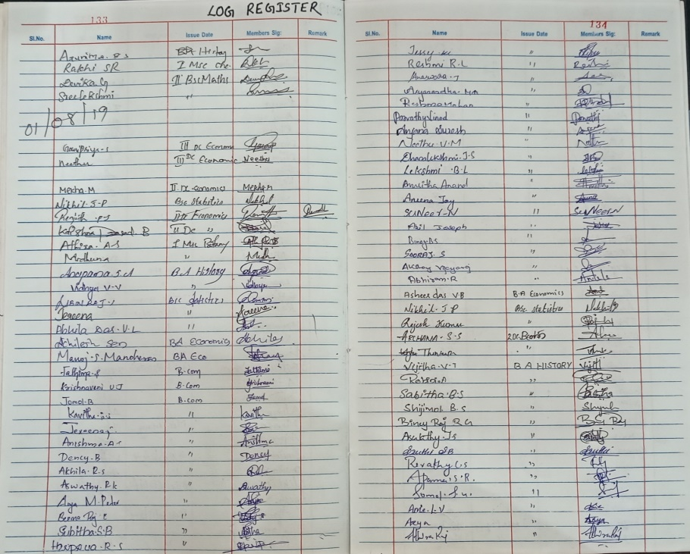

*Source:* *ccklibrary.wordpress.com*

Figure 1.0 Physical Log Entry/ Log Register Book

Library access records, often referred to as visitor logs (see Figure 1.0) or attendance sheets, play a vital role in monitoring user engagement and ensuring accountability within academic institutions. These records document key details such as user identity, purpose of visit, date, and time of entry—data which can later be analyzed for service improvement or institutional reporting.

According to Owen (2016), maintaining accurate records of library usage is crucial for understanding patron behavior, justifying budget allocations, and evaluating resource planning. It also aids in tracking trends over time and identifying peak usage periods, which is essential for staffing and facility optimization.

In the study of modern academic libraries, Singh and Kaur (2019) emphasized that access records are increasingly digitized to reduce errors, prevent duplicate entries, and enable real-time analytics. These digital logs are particularly beneficial when integrated with Library Management Systems (LMS), as they automate data validation and allow for secure, centralized storage.

Furthermore, CHED guidelines on educational institutions’ quality assurance support the use of usage records to monitor the effectiveness of library services. Digital access records contribute to this goal by offering structured, timestamped logs that can be filtered and reported during internal or external audits.

The proposed LMS includes a Library Access Record module that supports these standards by capturing visitor names, roles, and visit purposes, while preventing duplicate borrowing or return entries on the same day. This not only improves operational efficiency but also supports institutional data governance and reporting practices.

*Features Found in Standard Library Management Systems*

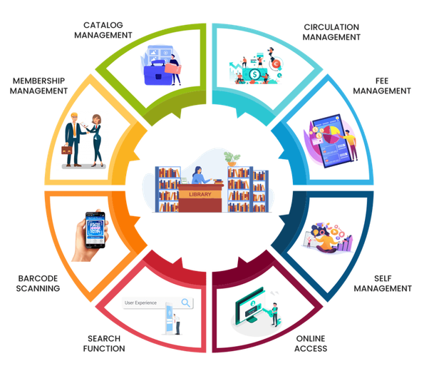

*Source: Wikipedia*

Figure 2.0 Key Features of Library Systems

Standard library management systems, according to Edusuite, include essential features like the one shown in Figure 2.0, such as catalog management for organizing and categorizing books and other resources, user management for handling different access levels for library members, staff, and administrators, and circulation management to oversee lending processes including check-ins, check-outs, renewals, and reservations. Inventory management is also a critical feature, helping to track acquisitions and maintain up-to-date records of the library’s holdings. Additionally, these systems generate various reports on library usage, inventory status, and user activity to support decision-making and improve services​.

Integration with other educational and administrative systems ensures seamless operation and data sharing, enhancing the overall efficiency of library management systems. They also offer an Online Public Access Catalog (OPAC), providing users with an online interface to search the catalog, check the availability of items, and manage their accounts. Security features are incorporated to protect data, ensure user privacy, and secure transactions, making these systems user-friendly and reliable for all library operations​.

A Library Management System, as described by GeeksforGeeks, encompasses key features designed to facilitate efficient library operations and enhance user experience. It includes functionalities such as cataloging books with detailed information, managing member registrations and memberships, facilitating check-in and check-out processes, handling reservations and renewals, managing fines for overdue items, generating insightful reports on library usage, providing a user-friendly search interface for accessing library resources, sending notifications for due dates and reservations, and ensuring secure access controls. These features collectively aim to streamline library management, improve accessibility to resources, and enhance overall administrative efficiency and user satisfaction within the library environment.

*CHED Standards for Academic Libraries*



*Source: Wikipedia*

Figure 3.0 – CHED Logo

In the Philippines, the Commission on Higher Education (CHED) (see Figure 3.0) sets minimum requirements for academic libraries to ensure that they provide adequate support to teaching, research, and community extension services. These standards are outlined in CHED Memorandum Order (CMO) No. 1, series of 2014, which mandates the proper organization, staffing, services, and automation of academic libraries in higher education institutions (HEIs).

According to CHED, a modern academic library must provide: (1) a system for cataloging and classification of materials, (2) an efficient circulation system,(3) reference and research assistance, (4) updated statistical and usage reports, and (5) access to both print and digital materials.

The memorandum also encourages the automation of library operations, recognizing the role of technology in improving service delivery and information access. This includes the use of Library Management Systems (LMS) that allow for the digital tracking of book inventories, borrowing and return transactions, and visitor activity.

In addition, CHED aligns with quality assurance frameworks such as ISO 9001:2015, requiring that institutional processes—including those in library systems—maintain structured documentation, data integrity, and traceable transactions. These policies underscore the need for systems that are not only functional but also auditable and sustainable.

By incorporating modules for book management, OPAC, borrowing/return tracking, reporting, user authentication, and visitor logs, the proposed LMS is designed in accordance with CHED’s digital transformation objectives and quality benchmarks for academic libraries.

*Online Public Access Catalog (OPAC)*

According to Techopedia, an Online Public Access Catalog (OPAC) is an online database of materials held by a library or group of libraries. It provides searchable access to a wide range of information, including books, journals, audiovisual materials, and other resources. OPACs allow users to search for specific items, check their availability, and sometimes even access digital content directly. They are essential tools for patrons to locate and access library materials remotely or within the library itself.

*MARC (Machine-Readable Cataloging) standards*

According to (Seikel & Steele, 2011), the MARC (Machine-Readable Cataloging) standards are a set of digital formats developed in the 1960s by the Library of Congress to encode bibliographic information for library materials, facilitating the sharing and management of catalog records across different library systems. MARC records are structured into fields and subfields, each designated for specific types of information such as author, title, and publication date, enabling consistent and efficient cataloging practices. Over time, MARC has evolved to accommodate new types of materials and technological advancements, with MARC 21 being the most widely adopted version today.

Despite its widespread use, there is ongoing discussion within the academic community about the limitations of MARC in the context of modern data sharing and interoperability, leading to initiatives aimed at developing successor standards that leverage linked data principles.

In addition to its primary function of facilitating efficient cataloging, MARC standards play a crucial role in resource sharing across libraries worldwide. By enabling uniformity in how bibliographic information is structured, MARC allows libraries to exchange records, making it easier for users to access materials across different systems. However, as digital technologies and metadata standards evolve, there has been increasing pressure to transition from MARC to more flexible and interoperable systems. BIBFRAME (Bibliographic Framework) has emerged as a potential successor, leveraging linked data principles to create more dynamic and interconnected library metadata. Despite the push for newer standards, MARC remains a critical part of library infrastructure due to its extensive adoption and the challenges associated with migrating to new formats.

*Manual Library Systems*

According to Burke (2007) Manual Library Management systems, operating systems are vulnerable to human error. For instance, a librarian who misfiles a borrower's records or indexes a book incorrectly slows down the process and wastes students' time. Manual systems are also slow to operate. Instead of using a computer to issue and take back books, locating and updating a card index is slow and laborious. Manual systems are unable to store large amounts of data efficiently. With manual systems Librarian spend a lot of their time on mechanical, clerical tasks rather than liaising with library visitors.

Norhazifa et al. (2023) Manual library management requires a higher workforce for librarians and causes discrepancies during data encoding. The transaction history is too numerous and needs to be stored over a long period of time, requiring a lot of files for storage. With the advent of digital technology and the increasing complexity of library functions, traditional manual systems have become inefficient and time-consuming.

*Accession Records*

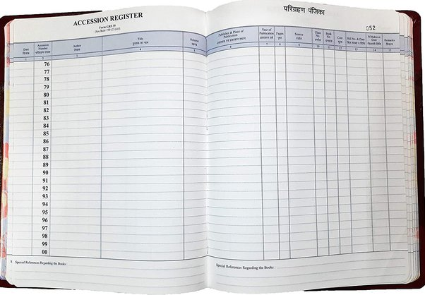

*Source: Quora*

Figure 4.0 – Accession Book Record

According to the National Institute of Open Schooling (NIOS), the accession records in a library like the one shown in Figure 4.0, serves as an inventory of books and other materials received by the library. These records are essential for keeping track of each item, ensuring proper documentation and management within the library system.

The primary functions of accession records include:

* Documenting New Acquisitions: Recording details about new materials added to the library collection.
* Inventory Management: Keeping an updated inventory of all items in the library, which is crucial for library audits and stock-taking.
* Tracking Item History: Providing a historical record of all acquisitions, including donor information, purchase details, and dates of acquisition.

Accession records are typically maintained in an accession register, which includes fields such as accession number, date of acquisition, source, cost, and other relevant details about each item.

*Card Catalog*

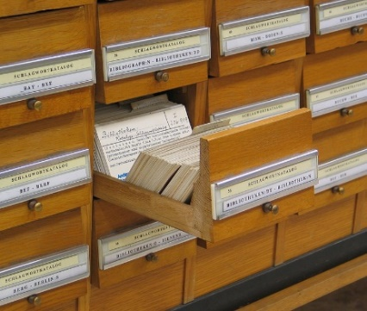

*Source: Wikipedia*

Figure 5.0 Card Catalog

The card catalog refers to the traditional system used by libraries to organize and provide access to their collections through physical index cards. These cards typically contain bibliographic information about each item in the library, such as title, author, publication details, and subject headings. The cards are organized alphabetically by author, title, and subject, facilitating easy retrieval of information by library users. This system was widely used before digital catalogs and databases became prevalent in libraries, offering a physical representation of the library's holdings that users could browse and search manually.

*Visual Studio*



*Source: Wikipedia*

Figure 6.0 Logo mark of Visual Studio 2022

Visual Studio (see the logo in Figure 6.0), developed by Microsoft, is an integrated development environment (IDE) for creating a variety of computer programs, including websites, web applications, web services, and mobile applications. It utilizes Microsoft development platforms like Windows API, Windows Forms, and Microsoft Silverlight, producing both native and managed code.

The IDE includes a code editor with IntelliSense (code completion) and code refactoring support, along with an integrated debugger that functions at both source and machine levels. Visual Studio also features a code profiler, GUI designer, web designer, class designer, and database schema designer. It supports plug-ins to extend functionality, including source control systems (e.g., Subversion, Git) and additional toolsets for domain-specific languages and other development lifecycle aspects like Azure DevOps (Team Explorer).

Visual Studio supports 36 programming languages, allowing the code editor and debugger to accommodate various languages, given the existence of a language-specific service. Built-in languages include C, C++, C++/CLI, Visual Basic .NET, C#, F#, JavaScript, TypeScript, XML, XSLT, HTML, and CSS. Additional languages, such as Python, Ruby, Node.js, and M, are supported through plug-ins, with previous support for Java and J#.

*Visual Basic .NET*



*Source: Wikipedia*

Figure 7.0 Logo mark of Visual Basic .Net

Visual Basic (VB) presented in Figure 7.0, is an object-oriented programming language and development environment developed by Microsoft in 1991, originating from the BASIC language (Beginners All-purpose Symbolic Instruction Code). It enables developers to create applications using graphical elements and a drag-and-drop interface to alter code, define object behaviors, and control appearances. VB is event-driven and designed for rapid application development (RAD), making it easy to learn and facilitating quick prototyping with minimal initial coding. VB's features include straightforward syntax, an intuitive visual environment, fast RAD capabilities, and robust database connectivity. These attributes make VB a powerful tool for building and updating software efficiently.

*Graphical User Interface (GUI)*

A Graphical User Interface (GUI) is a computer program that allows users to interact with a computer through symbols, visual metaphors, and pointing devices. It is most famously used in Apple's Macintosh and Microsoft's Windows operating systems. GUIs have replaced the complex textual interfaces of earlier computers with a more intuitive and user-friendly system, making computer use easier and more natural. GUIs have become the standard interface for computers, with their components now recognized as cultural artifacts.

*Windows 10*



*Source: Wikipedia*

Figure 8.0 The logo of Windows 10

According to Microsoft, Windows 10 (see Figure 8.0) is described as a major release of the Windows NT operating system. It serves as the successor to Windows 8.1 and was officially released on July 29, 2015. Windows 10 was made available as a free upgrade for users of Windows 7 and Windows 8.1 through the Microsoft Store and Windows Update. This operating system is designed to receive ongoing updates at no additional cost to users, ensuring that they always have access to the latest features and security improvements.

Additionally, Windows 10 offers different servicing options for enterprise environments, allowing organizations to receive updates at a slower pace or to use long-term support milestones for critical updates over a ten-year extended support period. This flexibility helps enterprises manage their IT infrastructure effectively while benefiting from the continuous improvements that Windows 10 provides.

*Windows Forms*

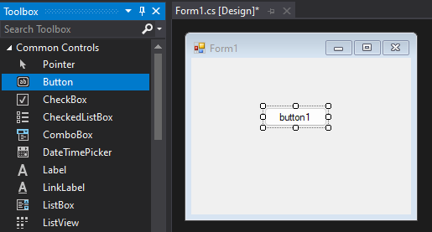

*Source: Microsoft*

Figure 9.0 Screenshot of Visual Studio’s Windows Forms

A Windows Forms (WinForms) application in Figure 9.0, is an application designed using a graphical subsystem originally developed by Microsoft for rendering user interfaces in Windows-based applications. WinForms provides a comprehensive environment for building rich desktop applications with features such as event-driven programming, drag-and-drop UI design, and built-in controls for efficient UI development.

In a WinForms app, the user interface is composed of a hierarchy of elements defined in .NET, which can be connected to backend logic through event handlers and data bindings. WinForms supports a variety of layout options, powerful styling capabilities, and a separation of concerns through an object-oriented approach. This allows developers to create applications with a clear division between the user interface and business logic.

By leveraging these tools, WinForms aims to streamline the design-to-development process, making it easier to create and maintain Windows-based applications.*Figma.*

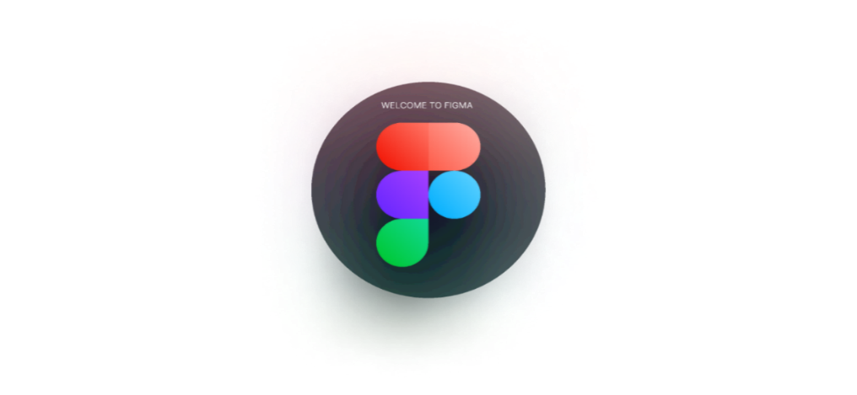

*Source: Figma*

Figure 10.0 Figma Logo

Figma shown in Figure 10.0, is a cloud-based vector graphics editor and prototyping tool primarily used for UI and UX design. It allows designers to create and collaborate on designs in real time directly from their browser, which means there's no need for multiple licenses or installations across different platforms. Figma supports a wide range of design activities, including creating wireframes, prototypes, and high-fidelity designs for web, mobile, and desktop applications.

WPF (Windows Presentation Foundation) UI design emphasizes the integration of its design tools with development workflows, particularly through the Uno Platform for Figma plugin.



*Source: Wikipedia*

Figure 11.0 The Uno Platform open-source project logo

This plugin allows designers to export their Figma designs directly to XAML or C# markup, which can then be used for developing WPF applications. This seamless transition from design to development reduces the friction between designers and developers, facilitating a more efficient workflow.

The plugin includes features like live preview, auto layout, and the ability to override instance properties such as colors and fonts. It also supports exporting design assets, which helps developers ensure that the visual aspects of the application remain consistent with the original design. By leveraging these tools, the Uno Platform for Figma aims to streamline the design-to-development process, making it easier to create and maintain WPF applications​.

*Information Security and Access Control in Library Management Systems*

As libraries increasingly adopt digital platforms to manage their operations, ensuring information security and controlling access to sensitive data have become essential aspects of system design. Library Management Systems (LMS) store not only bibliographic records but also personal information about users, such as names, contact details, and borrowing history—making them potential targets for data breaches if not properly secured.

According to Smith and Wiggins (2018), implementing secure authentication mechanisms in library systems helps protect user privacy and institutional data. Techniques such as hashed passwords, role-based access control, and two-factor authentication are recommended practices that enhance system security while maintaining user accountability.

The principle of least privilege, as discussed by Bishop (2003), is especially important in LMS design. This principle limits users’ access rights to the minimum necessary for their roles, thereby reducing the risk of accidental or malicious misuse of data. In academic libraries, this translates to differentiated access levels between librarians, IT personnel, and administrators.

Security in LMS development also involves proper configuration of the database environment. Tools like SQL Server Management Studio (SSMS) provide granular control over user roles, database permissions, and data encryption options. As noted by Krishna and Sharma (2020), SSMS enables database administrators to audit activity logs, enforce access rules, and monitor sensitive operations, ensuring that data remains secure and consistent across sessions.

Modern security practices in LMSs further include forced password change upon first login and input validation to prevent SQL injection or unauthorized data manipulation. These mechanisms not only secure the system technically but also build user trust in digital library platforms.

The proposed ESTI LMS applies these principles by incorporating SHA-256 password hashing, OTP-based two-factor authentication, default password enforcement, role-based admin controls, and secure database management via SSMS—demonstrating its compliance with current best practices in information security for educational systems.

*Reporting and Document Generation in Academic Libraries*

In academic library settings, the ability to generate reports is essential for decision-making, performance monitoring, and institutional compliance. Reports enable librarians and administrators to evaluate resource usage, track borrowing trends, and document visitor activity. These records are often required during audits, accreditation processes, or CHED evaluations, and must be presented in a clear, consistent, and professional format.

According to Shafack and Takam (2018), reporting modules in Library Management Systems (LMS) not only support accountability but also provide transparency in operations, helping stakeholders understand how resources are used and identify areas for improvement. Digital reporting tools also eliminate the inefficiencies and inaccuracies associated with manual report generation.

PDF remains one of the most reliable formats for official academic documentation due to its fixed layout, cross-platform compatibility, and print-readiness. As Kettunen (2021) points out, PDF generation in library systems enables institutions to maintain uniform documentation that reflects branding elements such as logos, headers, and institutional information—factors that enhance professionalism and institutional credibility.

Libraries that adopt technologies like iTextSharp, a .NET-compatible PDF generation library, can automate the creation of printable reports from database content. These may include lists of accessioned books, log entries, borrowing histories, or overdue summaries, which are essential for internal recordkeeping and regulatory reporting.

In the proposed LMS, the Export to PDF feature is used to produce structured reports of books and library activity. These reports follow a consistent layout with institutional branding and are exportable on demand. This function not only improves efficiency but ensures that the school is prepared to present updated records in professional formats when required by CHED or internal administration.

*Portable Document Format (PDF)*



*Source: Wikipedia*

Figure 12.0 Adobe PDF icon

According to Adobe, PDF stands for Portable Document Format, a versatile file format created by Adobe to present and exchange documents reliably, independent of software, hardware, or operating systems. Now an open standard maintained by ISO, PDFs can include links, buttons, form fields, multimedia, and business logic. They support electronic signatures and can be easily viewed on Windows or macOS using free software like Adobe Acrobat Reader.

WPF applications can generate PDF files using several methods. Third-party libraries like iTextSharp, PDFSharp, and Syncfusion Essential PDF provide APIs for programmatically creating PDF documents with text, images, and tables. Tools such as Winnovative XAML to PDF Converter convert WPF's XAML content directly into PDF format, preserving existing layouts. Alternatively, .NET's PrintDocument class facilitates rendering WPF content to PDF through physical or virtual PDF printers. For customized PDF generation, libraries like Pdfium or PdfBox offer low-level APIs. Integration with reporting tools such as Crystal Reports or DevExpress Reporting streamlines the creation of structured PDF reports from WPF applications, catering to diverse layout needs and performance considerations.

*Laptop*

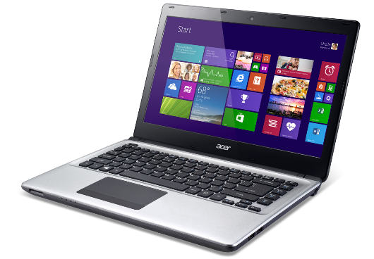

*Source: PNGWing.com*

Figure 13.0 Laptop

According to TechTarget, a laptop is a portable personal computer with a built-in screen and keyboard. It typically features a clamshell design, allowing the screen and keyboard to fold together for easy transport. Laptops are powered by batteries or an external power supply, making them convenient for mobile use. They are equipped with various ports for connectivity, such as USB, HDMI, and headphone jacks, and come with built-in wireless capabilities for internet access and peripheral connections. Laptops are versatile devices used for a range of tasks, from basic web browsing and document editing to more demanding applications like gaming and professional software development.

Academic studies have demonstrated that laptops can significantly enhance the programming experience, especially when integrated effectively into educational settings. According to Fisher, B. (2020, June 9) from the University of Michigan, integrating laptops with tools that facilitate in-class activities like note-taking, annotating slides, and engaging with lecture content can increase student engagement and perceived learning outcomes. Students reported higher levels of engagement and learning in courses that incorporated structured laptop use compared to those that allowed laptop use without specific instructional integration​

*Intel Core Processor*

Intel Core is a series of multi-core (excluding Core Solo and Core 2 Solo) CPUs designed for midrange, embedded, workstation, high-end, and enthusiast computers, produced by Intel Corporation. These processors replaced the mid- to high-end Pentium processors upon their release, relegating the Pentium line to entry-level positions. Equivalent or more advanced versions of Core processors are also available as Xeon processors for server and workstation applications.

The performance of Intel Core processors in software development has been the subject of several academic studies. A study by Forsell, M. et. al. compared the performance and programmability of Intel Skylake client and server multicore CPUs with other architectures, focusing on kernel benchmarks widely used in general-purpose computing. This research evaluated different programming approaches and their impact on performance, highlighting the efficiency of Skylake processors in executing various tasks relevant to software development​.

Parthasarathi, R. (n.d.) discussed the features of Intel’s multicore architectures, including Hyper-Threading and Turbo Boost technologies, which enhance the performance of software applications. Hyper-Threading allows multiple threads to be processed simultaneously, increasing system efficiency, while Turbo Boost technology dynamically adjusts the processor's frequency to optimize performance based on workload demands. These features make Intel Core processors particularly effective for software development, offering higher throughput and responsiveness for multithreaded applications​.

*RAM Size*

Studies and expert guidelines suggest that the optimal RAM size for software development depends on various factors, including the complexity of the projects, the development environment, and the specific programming tools used. For basic coding tasks, a minimum of 8GB of RAM is generally sufficient to ensure smooth performance and prevent slowdowns. Idoko, N. (2023, October 20). However, for more complex projects or resource-intensive tasks, such as those involving virtual machines, large datasets, or advanced graphic design, 16GB or even 32GB of RAM is recommended. This higher RAM capacity supports smoother multitasking, faster compilation, and more efficient debugging and execution of code. (Teslyuk, V., Batyuk, A., & Voityshyn, V. 2024)

*SQL Server*

SQL Server, according to TechTarget, is a relational database management system (RDBMS) developed by Microsoft. It is designed to store and retrieve data requested by other software applications, which can run on the same computer or across a network. It uses Structured Query Language (SQL) for database management and operations such as data querying, updating, inserting, and deleting.

SQL Server supports various transaction processing, business intelligence, and analytics applications in corporate IT environments. It offers a broad range of services including database creation, integration, replication, analysis, and reporting. It’s commonly deployed in cloud, hybrid, and on-premises infrastructures, enabling businesses to manage large volumes of structured data efficiently.

Microsoft regularly updates SQL Server to enhance performance, security, and scalability, and it includes features such as advanced analytics and machine learning integrations​

*SQL Server Management Studio (SSMS)*

SQL Server Management Studio (SSMS) is a widely adopted integrated environment for managing Microsoft SQL Server databases. It provides developers and database administrators (DBAs) with tools to configure, monitor, and maintain databases through a graphical user interface and T-SQL scripting. SSMS is especially useful in academic software development projects due to its accessibility, visual management capabilities, and strong support for structured data handling.

According to Rahimi and Haug (2019), SSMS enables efficient creation and management of database schemas, stored procedures, triggers, and user-defined functions, which are essential components in transaction-heavy systems like Library Management Systems (LMS). Through its object explorer and query tools, users can interact with database elements, test queries, and visualize table relationships in a structured way.

One of the key strengths of SSMS lies in its security and access control features. As noted by Krishna and Sharma (2020), SSMS allows database administrators to assign user roles, manage authentication modes (SQL or Windows), and enforce permission-based access to sensitive data. These tools are critical in applications that store personal information or usage logs, such as academic LMS platforms.

In the context of this study, SSMS was used to build and manage the LMS database, including its tables for book records, transactions, users, and log entries. It also facilitated the creation of SQL queries used for statistics, filters, and overdue book detection. The use of SSMS contributed to data integrity, optimized query execution, and secure storage—making it an essential backend tool in the development lifecycle of the system.

*History of Erhard Systems Technological Institute*



Figure 14.0 Erhard Systems Technological Institute

Educational System Technological Institute (E.S.T.I) shown in Figure 14.0, was founded in 1990 to pioneer in computer education services in the province of Marinduque, Initially, only short term vocational courses, like Office management with computer technology and electronics technology were offered but us the need for four year academic programs became evident, the educational institution started offering B.S. in Computer Science and B.S. in Business Administration.

Marinduque being an island province has a fine tradition of producing competent seafarers. These professionals are well respected and admired by the local community such that many among the youth aspire to become one of them. This fact and the clamor of the community paved the way for the institutions opening of the maritime school.

One year and two-year seaman training programs, both vocational courses, were offered first. Then on June 1986, B.S. in Marine Transportation was introduce. On June 1998, E.S.T.I started instituting a quality system with the vision of enhancement management efficiency and providing better services to its clients. The first phase was spent documenting operating procedures in every aspect of operation. Gradually, quality practices were applied, and finally culminating the development of a quality standard System Manual.

The Quality Standard System Manual is based on the ISO 9001 model and contains the policies on which the quality assurance of the institution is based. Policies, procedures and other documents, which define the way the institution conduct business, are commercial-in-confidence, so they may not be released outside the institute. The quality assurance system is documented to ensure control of all activities within the institute and to limit risks encountered. It is hoped that the continuous quality improvement effort within the institute will be prime mechanism by which the quality assurance system becomes more efficient and effective.

Then, with the untiring efforts of everybody in the institution put together, the institution was granted 100% full compliance by the commission on higher Education. On June 22, 2001, the Quality Management System of E.S.T.I has fully complied with the ISO 901:1994/PNS 9001:1994 requirements and was certified by Lloyds Register Quality Assurance (LRQA) up to the year 2003. Thereafter, the Society General de surveillance (GS) of genera, Switzerland was the ISO 9001:2000 certifying body of E.S.T.I up to the year 2007. At present E.S.T.I is ISO certified by Bureau Veritas Philippines Inc. version ISO 9001:2008. As of now, E.S.T.I continues to comply with the standard requirements of the commission on Higher (CHED), technical Education and skills Development Authority (TESDA), and STCW 1995.

International Organization for Standardization (ISO) 9001:2008 certification assures the students, parents and community in general that the management system and quality of education being provided by E.S.T.I is at part with internationally accepted standards. ESTI at present is the only organization or corporation with an ISO 9001-2008 certification in the whole province of Marinduque. To be able to extend quality education to other areas, E.S.T.I established branches in Odiongan, Romblon and San Jose, Oriental Mindoro in year 2000 and 2003 respectively. In year 2013, Erhard Science College, a branch of San Rafael, Bulacan was established.

**Related Studies**

*iSLIM - Library Management System*

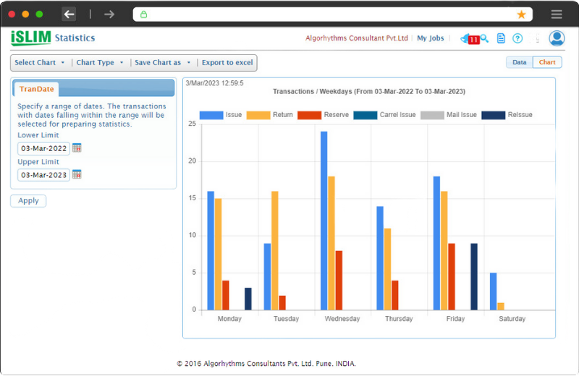

*Source: slimkm.com*

Figure 15.0 iSlim LMS User interface

Library management systems (LMS) are crucial for improving the efficiency and effectiveness of library operations. They automate routine tasks such as cataloging, circulation, and inventory management, reducing the time and effort required by staff and allowing them to focus on more valuable activities. This automation leads to better resource utilization, even with limited budgets, and enhances overall productivity. Additionally, LMS software maintains and manages library data, including budgeting, classification, and circulation records, ensuring secure storage and easy access, which supports better decision-making and service improvement​. (Satish, 2023)

Modern LMS solutions like iSLIM in Figure 15.0, offer user-friendly interfaces that simplify operations, making them easy to operate for both staff and patrons. Features such as automated checkouts, renewals, and an online catalog accessible from any device enhance convenience. LMS also plays a vital role in managing inventory by tracking borrowed and returned items, reducing overdue books, and ensuring adequate stock of new materials. This not only maintains an efficient inventory system but also improves customer service. Moreover, the cost-efficiency of LMS, achieved through reduced manual labor and maintenance, makes it a valuable investment for libraries, often paying off quickly due to significant savings over time.

*Koha*



*Source: Facebook*

Figure 16.0 Koha Integrated Library System

Koha (see Figure 16.0), is a widely used open-source integrated library system (ILS) designed to manage various library tasks efficiently. Developed in 1999 by Katipo Communications for the Horowhenua Library Trust in New Zealand, Koha is known for its flexibility, scalability, and comprehensive feature set. It supports cataloging, circulation, acquisitions, serials management, and patron management, making it suitable for libraries of all sizes and types. Koha's web-based interface allows users to access the system from any device with internet connectivity, enhancing its usability and accessibility​.

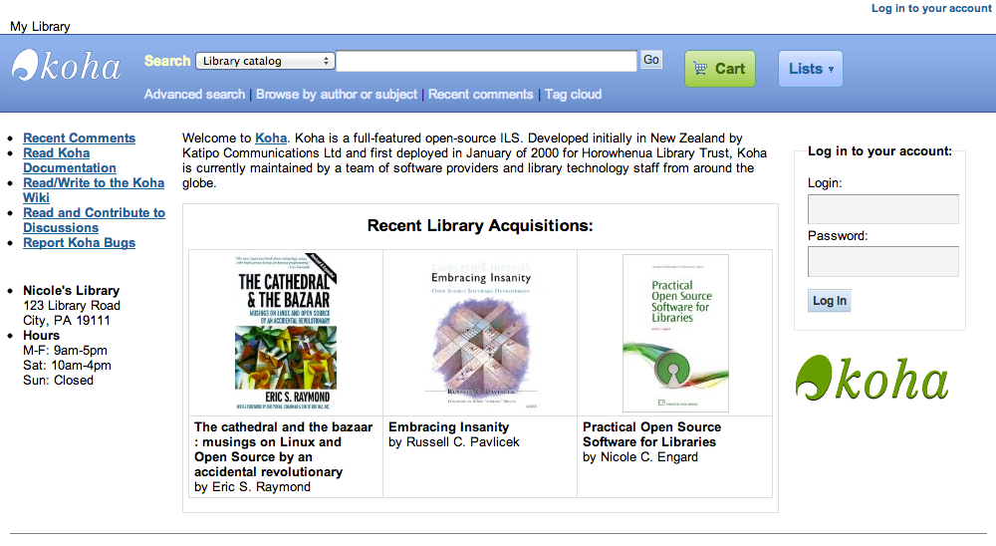

*Source: bluelinktech.com*

Figure 17.0 Koha User Interface

Koha (see Figure 17.0) is highly customizable, with numerous plugins and modules available to extend its functionality. It supports MARC21 and UNIMARC standards, facilitating seamless cataloging and data exchange. Additionally, Koha includes a powerful reporting module that allows libraries to generate detailed reports on various aspects of their operations. Its open-source nature means that libraries can adapt and modify the system to meet their specific needs, and they benefit from a global community of users and developers who contribute to its ongoing improvement and support​.

*CodeAchi Library Management System*

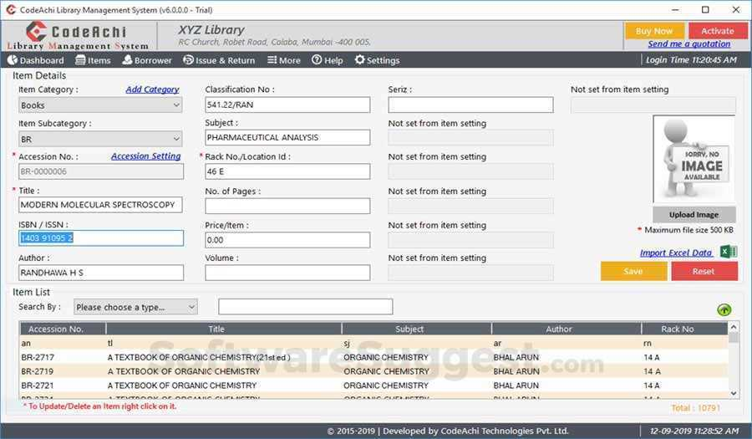

*Source: softwaresuggest.com*

Figure 18.0 CodeAchi User Interface

The CodeAchi Library Management System in Figure 18.0, offers a variety of features that streamline library operations, making it suitable for educational institutions and small to medium-sized libraries. Key features include cataloging, book lending, ID card creation, barcode printing, and report generation. The software is noted for its user-friendly interface, which simplifies the process of importing books and managing student data via Excel sheets. This system also allows for the tracking of book locations and generates detailed reports, making library management more efficient.

Users have praised CodeAchi for its excellent customer support and ease of use. The software also includes features for creating book categories, sending notifications, and managing member records. However, some users have noted areas for improvement, such as enhancing the book return process and providing better support for Linux platforms. Overall, CodeAchi is highly recommended for its functionality and the responsive support provided by its team, making it a valuable tool for librarians​.

*UP Integrated Library System (iLib)*

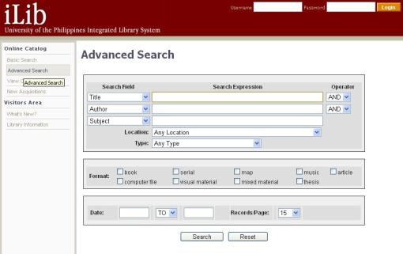

*Source: softwaresuggest.com*

Figure 19.0 CodeAchi User Interface

The UP Integrated Library System (iLib) in Figure 19.0, is a comprehensive library management system designed to facilitate and enhance library operations across the University of the Philippines (UP) System. It serves as a centralized platform for managing essential library functions, ensuring efficient access to academic resources for students, faculty, and researchers. One of its core features is the Online Public Access Catalog (OPAC), which enables users to search for books, journals, theses, and other materials using advanced search filters. Additionally, the circulation management module oversees borrowing, returning, and renewing materials, providing real-time tracking and automated notifications for due dates and overdue books. The system also incorporates user management, allowing the library to maintain user profiles and implement borrowing privileges based on user categories, while enabling self-service transactions such as online renewals and reservations.

To support efficient cataloging, iLib adheres to Machine-Readable Cataloging (MARC) standards, ensuring consistency in bibliographic records and authority control for indexing authors, subjects, and titles. It also includes acquisitions and collection development features, which track purchase requests, orders, and budget allocations to help libraries manage resource procurement effectively. Furthermore, serials and subscription management ensures organized tracking of journals, magazines, and newspapers, facilitating seamless renewal processes for print and electronic serials. Recognizing the importance of digital resources, iLib integrates a digital repository and thesis archiving system, allowing for the secure storage and controlled access of electronic research materials while enabling full-text search capabilities.

Beyond individual campus operations, iLib supports interlibrary loan and resource sharing, enabling users to request materials from other UP libraries and access document delivery services. To aid in administrative decision-making, the system generates comprehensive reports and analytics, providing insights into library usage trends, circulation statistics, and collection development needs. Technically, iLib is a web-based system accessible through browsers and supports integration across multiple UP campuses, ensuring seamless data sharing. It also features secure user authentication through the UP Single Sign-On (SSO) system, enhancing security and accessibility. The system operates on a SQL-based database, ensuring efficient data storage and retrieval. By streamlining library workflows, iLib significantly enhances the overall efficiency of UP libraries, improving access to academic resources and optimizing library management processes.

**Conceptual Framework of the Study**

**OUTPUT**

**PROCESS**

**INPUT**

* Project conceptualization and data gathering
* Requirements analysis and definition
* Coding
* Software design and development
* Testing and debugging
* Evaluation

**Knowledge Requirements**

* Visual Studio IDE
* VB.NET programming language
* Windows Forms
* Library Management
* Software Development

**Software:**

* Visual Studio (VB.NET),
* Microsoft SQL Server (with TableAdapters),
* Microsoft Windows 10 operating system or higher,
* iTextSharp PDF library,
* QRCoder and Otp.NET libraries.
* SQL Server Management Studio (SSMS)

**Hardware:**

* Laptop
* Intel(R) Core(TM) i3-4005U CPU @ 1.70GHz 1.70 GHz
* 8.00 GB RAM
* 64-bit operating system, x64-based processor

**LMS: LIBRARY MANAGEMENT SYSTEM FOR ERHARD SYSTEMS TECHNOLOGICAL INSTITUTE**

**LMS**

**LMS**

**EVALUATION**

Figure 20.0 *The conceptual framework of the study*

Figure 20.0 shows the conceptual framework used in the design and development of the LMS: Library Management System for Erhard Systems Technological Institute to improve the efficiency of ESTI’s library management.

**Operational Definition of Terms**

Catalog refers to ESTI library manual library catalog.

Coding refers to the development of Library Management System (LMS) of Erhard Systems Technological Institute.

ESTI is an acronym for Erhard Systems Technological Institute.

GUI refers to the user interface of ESTI Library Management System (LMS).

Library refers to the Erhard Systems Technological Institute (ESTI) library.

LMS is an acronym for Library Management System. The project developed by the proponent for Erhard Systems Technological Institute.

Project refers to LMS: Library Management System of Erhard Systems Technological Institute.

Proponent refers to the researcher.

School refers to Erhard Systems Technological Institute (ESTI).

System refers to LMS: Library Management System of Erhard Systems Technological Institute.

User refers to a person that uses the LMS.

Chapter 3

**RESEARCH METHODOLOGY**

The project design, development, operation, and testing methods, as well as the assessment procedures, are all covered in this chapter.

**Project Design**

The aim of this study is to develop an efficient Library Management System for Erhard Systems Technological Institute (ESTI). Shown below in Figure 21.0 is the main form user interface design of the developed system.

*Main Form*

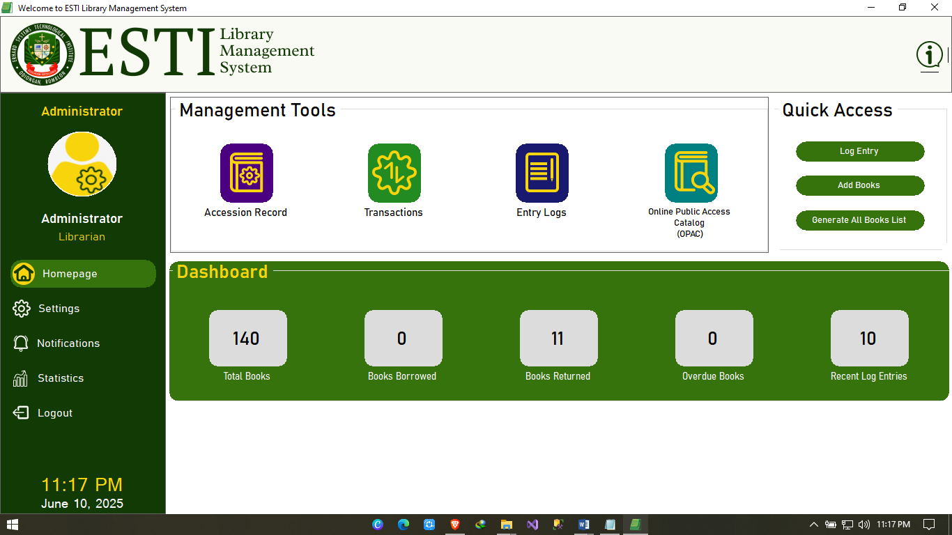

Figure 21.0 LMS User Interface – Homepage

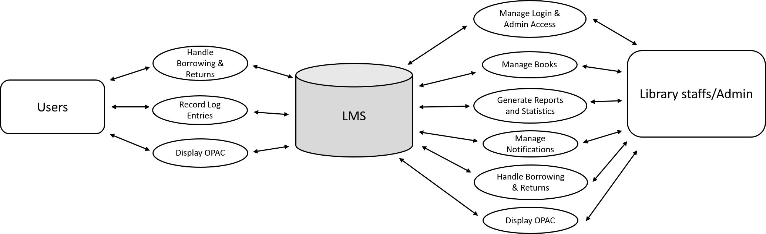

Figure 22.0 Data Flow Diagram of the Library Management System for Erhard Systems Technological Institute Level 1

The context diagram shown in figure 22.0. illustrates the features that a user and an administrator account has in control in the Library Management System. The context diagram outlines the interactions between the ESTI Library Management System (LMS) and various entities: Users and Library Staffs/Admin. Each entity provides specific inputs to the LMS: Library Staffs/Admin input login credentials, manage book records, log user visits, process borrow and return transactions, manage notifications, generate statistical reports, and control system access. Users provide information such as visit details, borrowing and returning requests, and book inquiries through the OPAC interface.

The outputs of the LMS vary for each entity. For Library Staffs/Admin, the system grants access to manage login authentication, book inventory, log records, borrowing and return processing, overdue notifications, statistical visualization, and report generation. For Users, the LMS allows viewing book availability, submitting borrow or return requests, and having their visits and transactions recorded by the system. All these interactions and operations are handled and stored within the central LMS database, ensuring reliable data processing, efficient transaction handling, and accurate record management for the institution’s library operations.

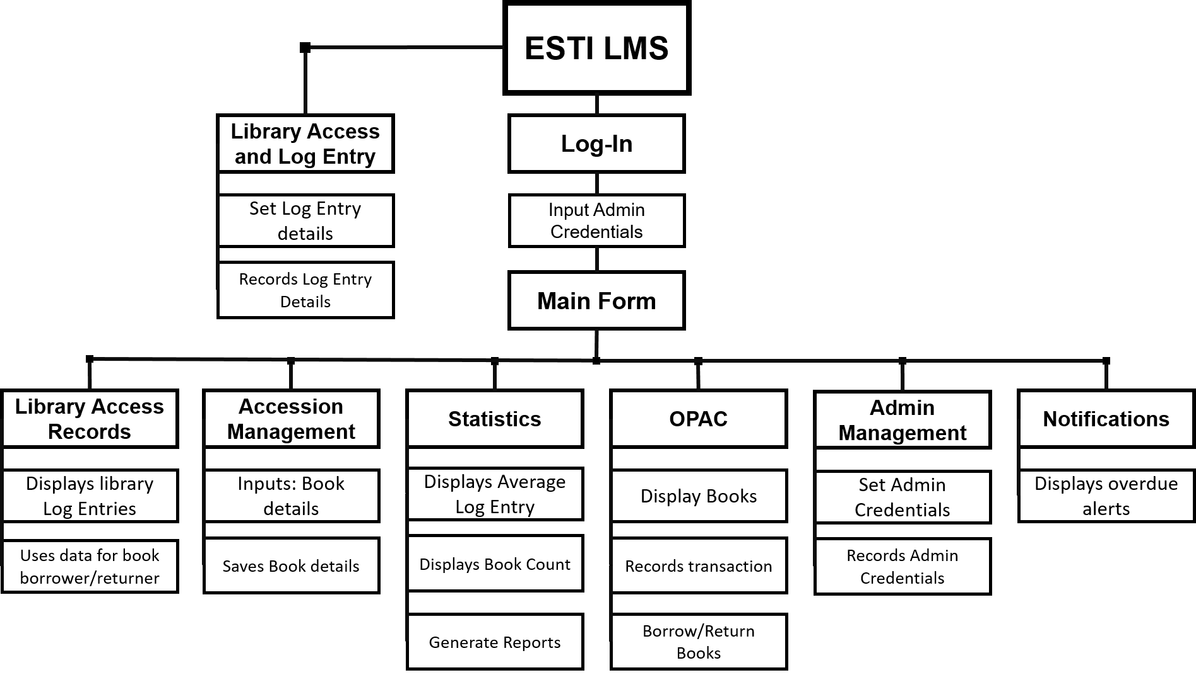

Figure 23.0 Hierarchy Input-Output (HIPO) Diagram of The Library Management System (LMS) for Erhard Systems Technological Institute.

The top-level of the Hierarchy Input-Output (HIPO) diagram presented in Figure 23.0 includes the ESTI LMS, which serves as the core of the system. Upon launch, the system presents two key entry modules: Library Access and Log Entry and Log-In. The Library Access and Log Entry module allows the admin to input and record log entry details such as visitor name, role, and purpose. This data supports other modules like transactions and reports.

The Log-In module requires administrators to input their credentials for access. Upon successful login, users are directed to the Main Form, which acts as the central dashboard and gateway to all other system functions.

From the Main Form, users can navigate to six functional areas: Library Access Records, Accession Management, Statistics, OPAC, Admin Management, and Notifications.

Library Access Records displays all log entries made by visitors and students and is used as a reference for borrowing and returning books.

Accession Management handles the input and saving of book information including title, author, material type, and year.

Statistics provides real-time visual summaries such as book count, average log entries, and includes the ability to generate system reports.

OPAC (Online Public Access Catalog) allows the display and searching of books. It also manages borrowing and return transactions.

Admin Management allows administrators to set or update admin credentials and manage access roles securely.

Notifications alerts the admin about overdue books by checking for unreturned items past their due date.

Each of these modules is integrated to ensure smooth library operations, real-time data access, and reliable administrative control within the ESTI LMS.

**Project Development**

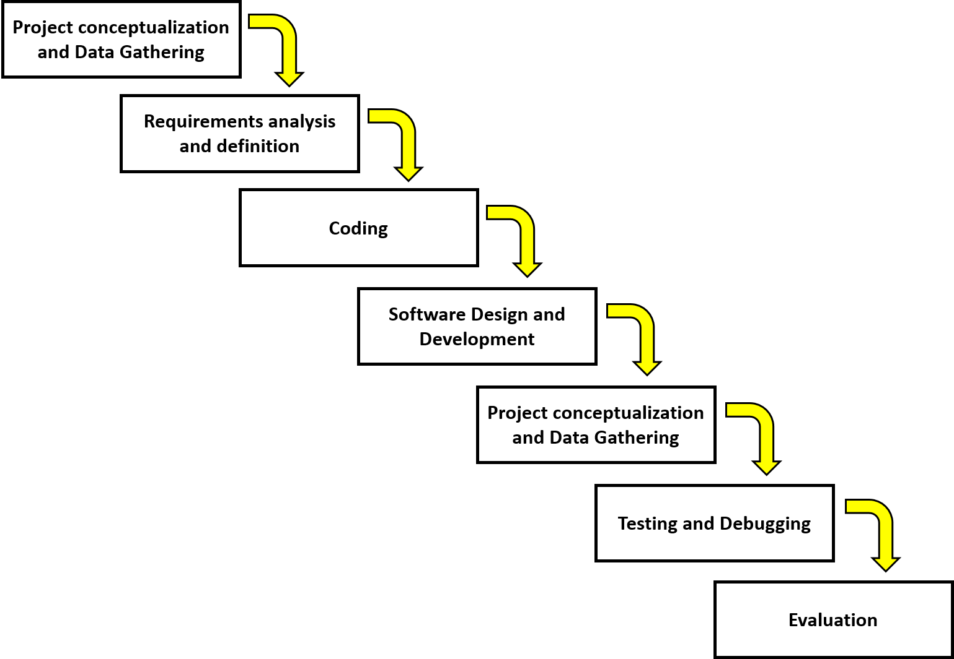

Figure 24.0 The Software Development Life Cycle (SDLC) used in the Library Management System (LMS) for Erhard Systems Technological Institute (ESTI)

Figure 24.0 above shows the software development life cycle (SDLC) used in the development of LMS: Library Management System for Erhard Systems Technological Institute (ESTI).

Figure 24.0 above shows the Software Development Life Cycle (SDLC) used in the development of LMS: Library Management System for Erhard Systems Technological Institute (ESTI).

Phase 1: Project Conceptualization and Data Gathering

The researcher initiated the study by gathering information from various online sources to understand the common issues that libraries frequently encounter.

To gain specific insights into the deficiencies faced by the school library, the researcher conducted an inquiry with the school librarian. This step was crucial for obtaining first-hand accounts of the challenges and operational inefficiencies observed within the school’s library system. The librarian provided detailed feedback on the issues.

In addition to the primary data collected from the librarian, the researcher also consulted academic journals and scholarly articles. These sources were essential for gathering credible and peer-reviewed information on Library Management Systems (LMS).

Phase 2: Requirements Analysis and Definition

The analysis of the development of the system and defining the requirements are included in this phase to determine if there is an opportunity in developing this program.

Phase 3: Coding

During this phase, the simulation program undergoes system and program design. System design focuses on modeling the program's user interface, while program design gives considerations from the programmer's perspective. This includes finalizing decisions on the programming language to be employed in development and selecting application programs for creating user interface elements like buttons, colors, and images for the Library Management System components.

Phase 4: Software Design and Development

This phase involves designing the overall structure of the Library Management System. The researcher outlines the architecture, user interface layouts, database schema, and module integration strategy. Development is then carried out based on the design specifications, focusing on writing efficient and maintainable code for each module, ensuring all features align with the defined requirements.

Phase 5: Testing and Debugging

The researcher deals with system testing, code tracing, identifying software bugs, errors, and other defects. Final module testing aims to demonstrate correctness, whereas testing during debugging is primarily aimed at locating errors.

Phase 6: Evaluation

After testing and debugging, the system undergoes evaluation to measure its overall effectiveness and efficiency. Feedback is gathered from actual users such as librarians and administrators to assess if the system meets its intended objectives. Any remaining issues are documented, and suggestions for future improvements are noted for possible system upgrades.

**Operation and Testing Procedure**

The following are the operation and testing procedures performed by the researchers.

*Operation Procedure:*

1. Conducted a requirements analysis through interviews with librarians and reviewed existing literature related to library management systems.
2. Identified and documented the functional and software requirements of the system.
3. Designed the system architecture, user interface flow, and database structure.
4. Developed the system using VB.NET for the interface and Microsoft SQL Server for database management.
5. Performed coding and integrated modules such as Book Management, Borrowing, OPAC, and Admin Control.
6. Conducted initial program testing and debugging to ensure each module functioned as intended.
7. Evaluated the developed system using the FURPS model to assess quality and usability.

*Testing Procedure:*

1. Opened the developed LMS application on a Windows-based system.
2. Logged in using administrator credentials to access the main dashboard.
3. Verified the login validation and redirection to Set Password form when default credentials were used.
4. Recorded a visitor's log entry by selecting their full name, role (Student, Teacher), and purpose (Borrowing or Returning).
5. Opened the Book Management module and added new book records, including title, author, and material type.
6. Searched books using the OPAC interface and verified filtering by title, author, and category.
7. Simulated a borrowing transaction and confirmed that the due date and borrower details were saved properly.
8. Returned a borrowed book and verified the system updated the return status and removed it from the overdue list.
9. Generated a PDF report for a selected material type and checked the formatting and content accuracy.
10. Tested the notification panel by marking an item as overdue and confirming its alert appearance.
11. Evaluated the Statistics Panel for correct display of book count, borrowed books, and log activity.
12. Verified that all buttons across modules performed their intended actions correctly.
13. Logged out of the system and closed the application.

*Evaluation Procedure*

The researchers will be using the FURPS model evaluation instrument to assess the developed Library Management System (LMS) in terms of Functionality, Usability, Reliability, Performance, and Supportability.

*Instruments and Techniques Used*

The evaluation of the Library Management System was conducted using a structured questionnaire. This instrument was developed based on the observation and feedback of selected respondents familiar with library operations. The questionnaire specifically incorporated the FURPS model to measure various aspects of system quality.

*Sampling Procedure*

Purposive sampling was employed to identify the respondents for this study. A total of 50 respondents, composed of librarians, staff, and selected students, were selected to evaluate the developed system based on their experience with library usage and administration.

*Statistical Treatment of Data*

The data gathered from the evaluation were analyzed using statistical techniques. The mean was used to determine whether the system met its intended requirements. Tally sheets and frequency tables were prepared to organize the data. The percentage was computed to reflect the proportion of responses per category.

The formula used for computing percentage is:

P = (f / n) × 100

Where:

P = percentage

f = frequency of a particular response

n = total number of responses

100 = multiplier to convert the result into percent

Weighted Mean

The weighted mean was used to summarize the ratings of the respondents based on their evaluation of the system. It was calculated by multiplying the frequency of each response by its corresponding scale value and then dividing the sum by the total number of respondents.

The formula used is:

X = ∑(f × x) / n

Where:

X = weighted mean

f = frequency

x = scale value

n = total number of respondents

∑ = summation symbol

The system was rated using a five-point Likert scale, defined as follows:

*Scale Interpretation*

5 - Very Strongly Agree

4 - Strongly Agree

3 - Agree

2 - Disagree

1 - Strongly Disagree

The resulting scores were interpreted using the descriptive scale below:

Weighted Mean Range Descriptive Rating

4.51 – 5.00 Very Strongly Agree

3.51 – 4.50 Strongly Agree

2.51 – 3.50 Agree

1.51 – 2.50 Disagree

1.00 – 1.50 Strongly Disagree

The results of this evaluation helped describe the perception of the users towards the system's effectiveness and its overall impact on improving library operations.

Chapter 4

**PRESENTATION, ANALYSIS, AND INTERPRETATION OF DATA**

This chapter presented the project description, project design, system capabilities and limitations, evaluation of the study, and the results obtained. The data gathered from the selected respondents regarding the Library Management System (LMS) of Erhard Systems Technological Institute (ESTI) were analyzed and interpreted.

**Project Description**

The Library Management System (LMS) developed for Erhard Systems Technological Institute (ESTI) consists of ten integrated modules, each designed to streamline specific library operations. These modules are: Login and Authentication, Admin Dashboard, Book Management, Borrowing and Return, Library Access Record, Online Public Access Catalog (OPAC), Statistics Dashboard, Notifications Panel, Report Generator, and Admin and Profile Management. Together, these components form a comprehensive desktop application that enhances both administrative control and user accessibility within the academic library environment.

The Login and Authentication module ensures secure access through password hashing, default password verification, and optional QR-based two-factor authentication. Upon successful login, users are directed to the Admin Dashboard, which serves as the control center for navigating system features and viewing key summaries. The Book Management module enables librarians to manage book accession, including metadata entry, thumbnail uploads, and the generation of unique Book IDs. The Borrowing and Return module handles lending operations, enforces due dates, updates return statuses, and flags overdue books for follow-up.

The Library Access Record module logs daily visitor entries, capturing names, roles, and purposes while preventing duplicate records. The OPAC module allows users to search and view books by title, author, or material type. The Statistics Dashboard visualizes essential data—such as borrowed books, returns, overdue items, and weekly log entries—through labeled graphs and counters. The Notifications Panel displays alerts, including overdue reminders, which users can acknowledge or remove. The Report Generator exports structured PDF reports with institutional branding. Finally, the Admin and Profile Management module supports account creation, role-based permission control, password updates, and profile editing.

**Hardware**

The hardware component of the Library Management System (LMS) for Erhard Systems Technological Institute (ESTI) includes a personal computer or laptop with the following minimum specifications: Intel Core i3-4005U CPU @ 1.70GHz, 8 GB RAM, and at least 80 GB of available hard disk space. These specifications are sufficient to support the operation of the LMS application, the database engine (SQL Server), and related components such as PDF generation and image handling for book thumbnails. The system is intended to run on a 64-bit operating system to ensure compatibility with the .NET framework and the required libraries for secure and efficient library operations.

**Software**

The software component of the Library Management System (LMS) for Erhard Systems Technological Institute (ESTI) consists of several key tools that support the development, deployment, and management of the application. The system operates on Microsoft Windows 10 or later (64-bit) as its platform, with Visual Studio using VB.NET as the primary development environment. Microsoft SQL Server is utilized for database management and data storage, while SQL Server Management Studio (SSMS) is used for administering and configuring the database. To generate branded and structured PDF reports, the system integrates the iTextSharp library. Security features, such as QR-based two-factor authentication, are implemented using the QRCoder and Otp.NET libraries. The system runs on the .NET Framework 4.x, which supports Windows Forms-based user interfaces and other essential dependencies. Collectively, these software components enable the LMS to deliver a secure, responsive, and CHED-compliant solution for modern library automation.

**Screen Layouts**

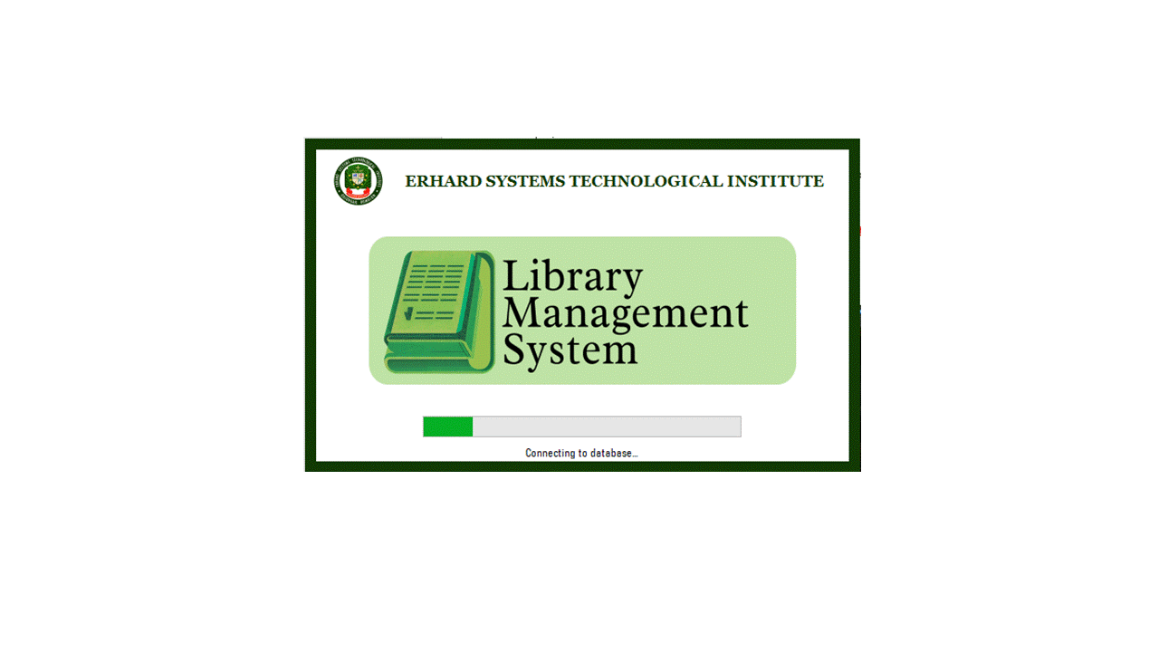

Figure 25.0 – Load Screen

Figure 25.0 displays the Load Screen of the Library Management System. This screen acts as a temporary splash interface while the system initializes key background processes necessary for operation. It appears upon launching the program and displays the institution’s logo, the system title, and a horizontal progress bar that visually indicates system loading. During this time, the system performs essential startup checks, such as verifying the database connection and checking if any admin accounts exist. If no administrator account is found, the system automatically prepares to launch the admin registration module. Once all checks and initializations are complete, the system proceeds to the Login Screen or account setup, depending on the current database state.

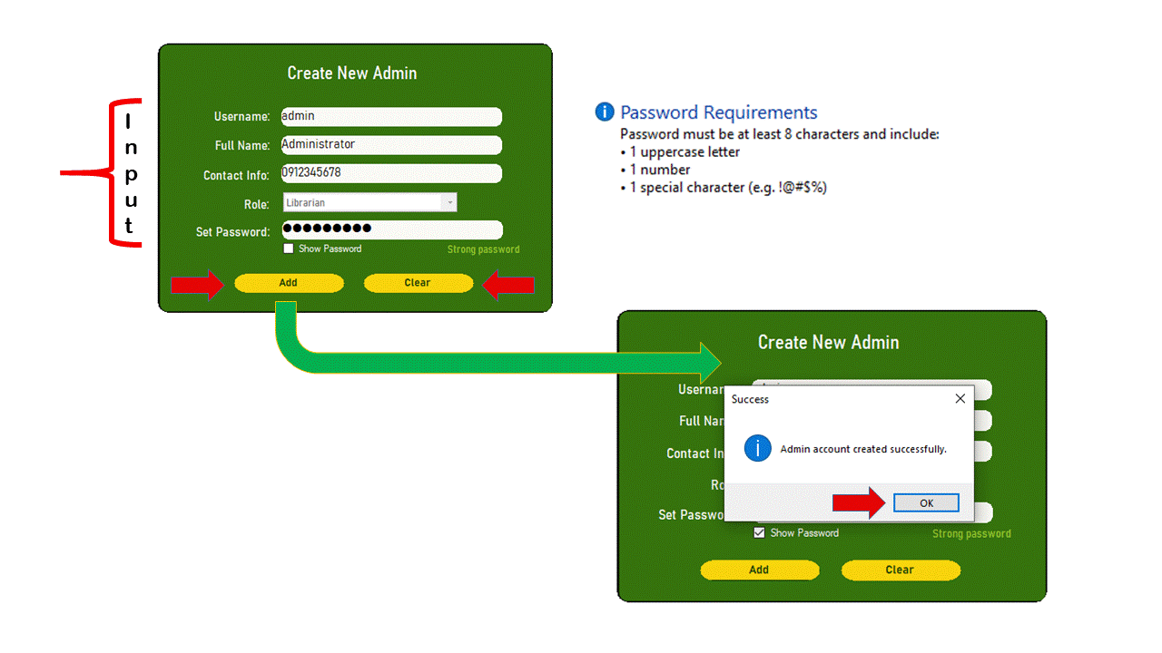 Figure 26.0 – Admin Registration Screen

Figure 26.0 shows the Admin Registration Screen, which appears if no administrator account exists during system startup. It allows the creation of the initial admin user by providing required inputs such as Username, Full Name, Contact Info, Role selection, and a password. The form includes password validation rules—requiring at least eight characters, one uppercase letter, one number, and one special character—with a strength indicator and an option to show or hide the password.

After filling out the form, clicking the “Add” button triggers validation and saves the account to the database. A confirmation message is shown upon success. The “Clear” button resets all fields. This screen ensures that system access is securely managed by authorized personnel only.

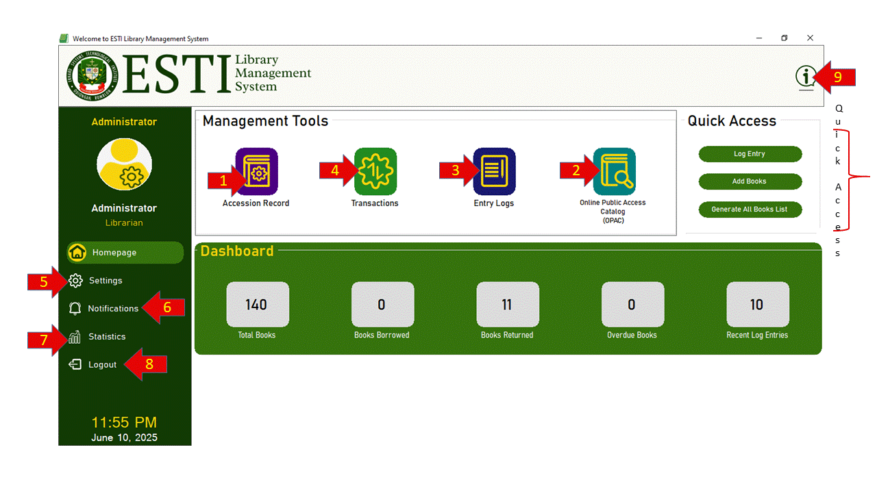 Figure 27.0 – Main Dashboard

Figure 27.0 illustrates the Main Dashboard of the Library Management System, which serves as the central interface for administrator users after successful login. This screen grants full access to all the core features of the system. The left-hand sidebar displays the administrator’s name, role, and a vertical navigation menu consisting of buttons for Homepage, Settings, Notifications, Statistics, and Logout. These allow the administrator to navigate seamlessly between modules and manage both user activity and system configurations.

At the center of the screen is the Management Tools section, where clickable icons provide direct access to the major modules: *Accession Record*, *Online Public Access Catalog (OPAC)*, *Entry Logs*, and *Transactions*. Each icon is numbered for visual guidance and arranged in order of use frequency. To the right is the Quick Access panel, designed for immediate actions such as logging a new entry, adding books, or generating a full list of all book records. These shortcuts help streamline repetitive tasks.

The bottom part of the interface features a real-time Dashboard summary displaying key statistics such as the total number of books, current borrow and return counts, overdue books, and recent log entries. A timestamp and current date are also displayed at the lower-left corner for system logging reference. Additionally, an information button in the top-right corner offers user assistance or system details when clicked.

This form serves as the main control hub for all administrative tasks, offering a well-organized, intuitive environment for managing library operations efficiently.

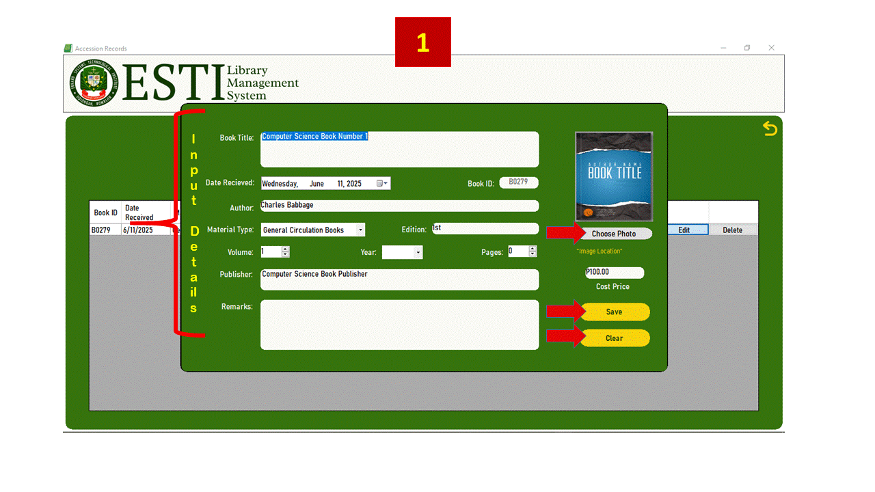

Figure 28.0 – Add Book Process Flow

Figure 28.0 illustrates the process flow for managing book entries in the system. When the administrator clicks on the *Accession Record* module, the system first checks if any books exist in the database. If no records are found, an informational prompt is displayed stating *“No books found. Please input book data before proceeding.”* This ensures that the Accession module is not accessed without valid book data.

After confirming, the system automatically opens the Add Book screen where the administrator is required to enter complete book details such as title, author, material type, volume, year, publisher, and cost price. A photo upload feature is also available via the Choose Photo button to attach a book cover image. Once all required fields are populated, clicking the Save button stores the new book in the database and displays a confirmation message. The Clear button resets all fields for fresh input.

Once at least one book record has been saved, the system redirects to the Accession Record interface, where the administrator can now view, manage, and filter all book entries. This process ensures proper initialization and continuity within the book cataloging system.

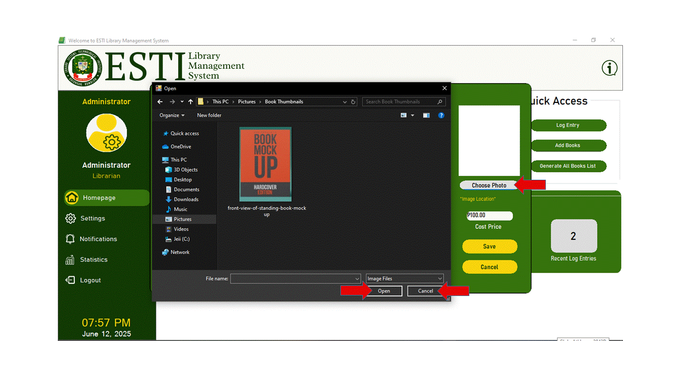

Figure 29.0 – Choose Photo Feature

Figure 29.0 illustrates the Choose Photo feature within the Add Book form. When the Choose Photo button is clicked, the system opens a file dialog window allowing the administrator to browse and select an image file from the local device. This image serves as the book's cover and will be displayed along with the book’s information throughout the system.

The file dialog filters supported image formats to ensure proper file compatibility. Once a file is selected and the Open button is pressed, the image is immediately previewed in the designated area of the form. This allows the administrator to confirm the correct image before saving the record. If needed, the Cancel button within the dialog can be used to close the window without selecting a file.

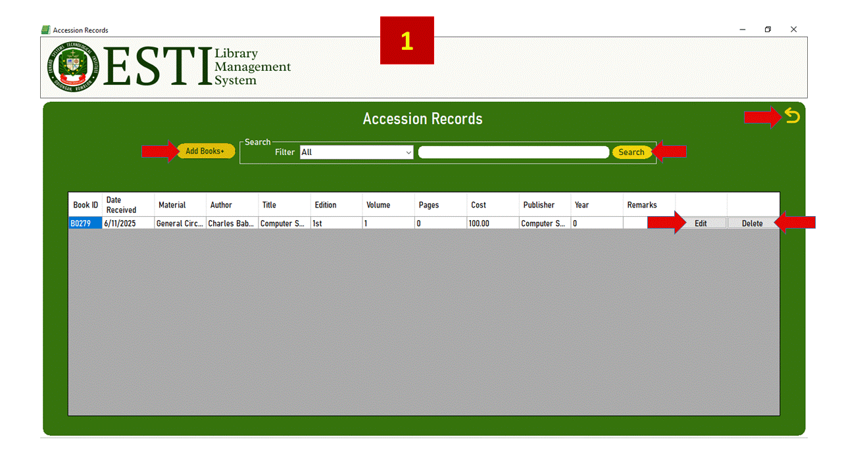 Figure 30.0 – Accession Record Table

Figure 30.0 displays the Accession Record screen, which provides a comprehensive view and management interface for all registered books in the system. Once books have been successfully added, they are displayed in a tabular format, showing details such as Book ID, Date Received, Material Type, Author, Title, Edition, Volume, Pages, Cost, Publisher, Year, and Remarks.

Administrators can perform key actions using the buttons provided. The Add Books button opens the Add Book form for registering new titles. Each row in the table includes Edit and Delete buttons, allowing users to modify or remove entries as needed. A Search bar and Filter dropdown help narrow results based on criteria such as material type or keyword.

Additionally, a Back button in the upper-right corner allows the user to return to the main dashboard. This module serves as the central access point for maintaining the library’s physical collection and supports efficient cataloging and inventory control.



Figure 31.0 – Edit Book Screen

Figure 31.0 shows the Add Book interface when accessed through the Edit function. This screen appears when the administrator clicks the Edit button beside a book record in the Accession Records module. When triggered, the system automatically pre-fills all input fields with the existing data from the selected row, allowing the administrator to update or correct the book details as needed.

The form includes editable fields such as Book Title, Author, Material Type, Volume, Edition, Publisher, Year, Pages, Remarks, and Cost Price. The current book cover image, if available, is displayed, and can be replaced using the Choose Photo button (see Figure 28.0). This opens a file dialog to select a new image, which will then be previewed on the form.

Clicking the Save button updates the record in the database with the new values, while the Clear button resets the form. This functionality supports accurate maintenance of book records and ensures that information remains up to date.

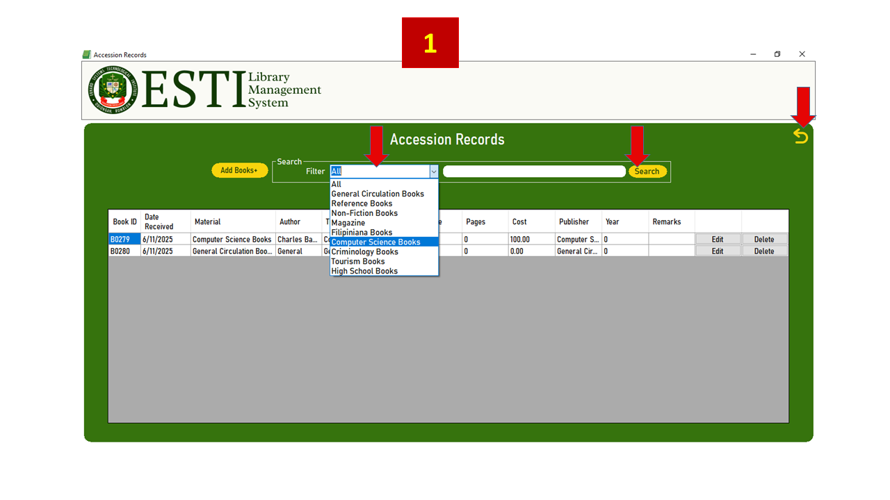

Figure 32.0 – Filter and Search Books

Figure 32.0 shows how to use the filter and search feature in the Accession Record screen. To narrow down the book list, first select a category from the Filter dropdown—such as General Circulation Books or Computer Science Books. This will limit the display to books under that type.

Next, you can type a keyword into the Search bar, such as part of a book title, author name, or publisher. Click the Search button to apply your search. Only books that match both the selected category and keyword will be shown. To go back to the main screen, click the Back arrow at the top-right corner.

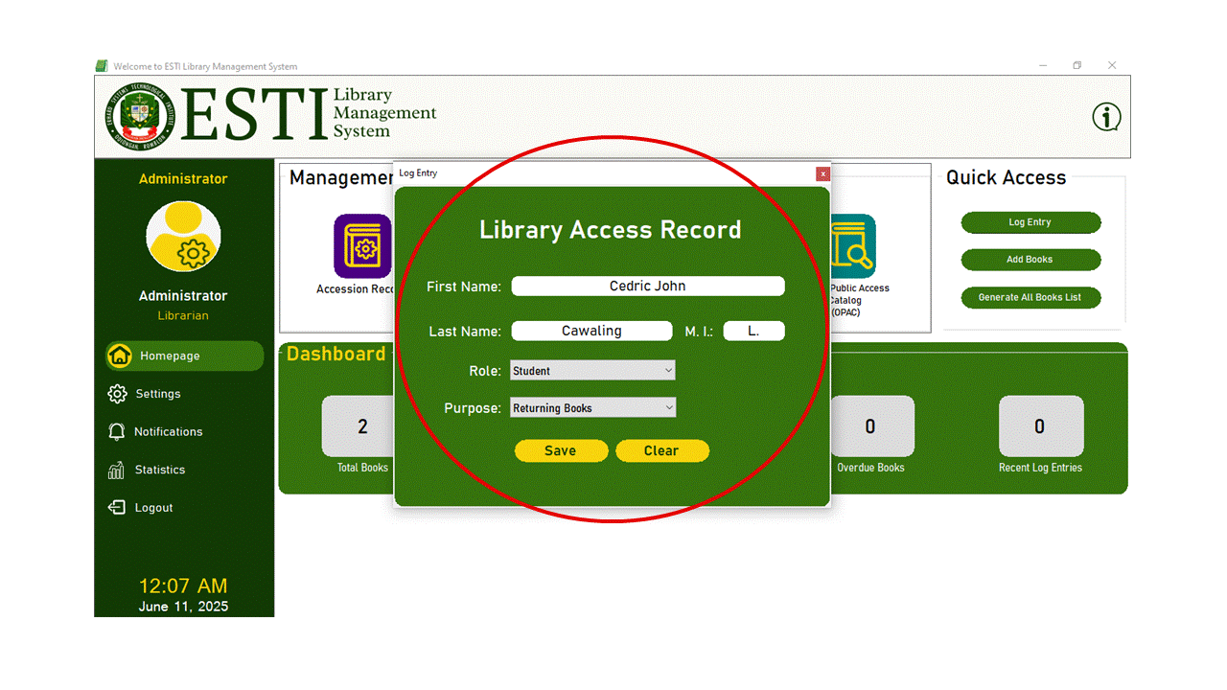

Figure 33.0 – Quick Access Library Access Record

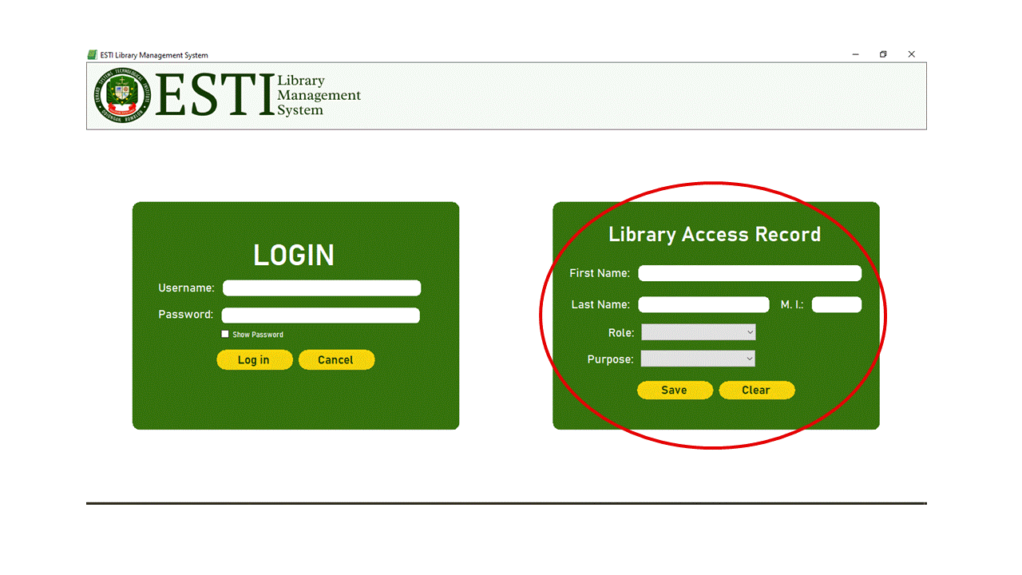

Figure 34.0 – Login Page Library Access Record

Figures 33.0 and 34.0 shows the Library Access Record form, used to record user visits to the library. This form is accessible from two locations: The Login screen, and the Quick Access panel on the dashboard. Users without login credentials can use this feature to register their presence and purpose during each visit.

To complete a log entry, users must fill in their First Name, Last Name, Middle Initial, and select their Role (Student, Teacher, or Visitor) and Purpose (Reading, Borrowing Books, Returning Books, Research, Printing, or Others). After completing the form, clicking Save records the entry in the database, while Clear resets the fields.

All records submitted here are stored in the Library Access Records for tracking and reporting purposes (see Figure 34.0). This form helps the system monitor library usage efficiently without requiring a system login.

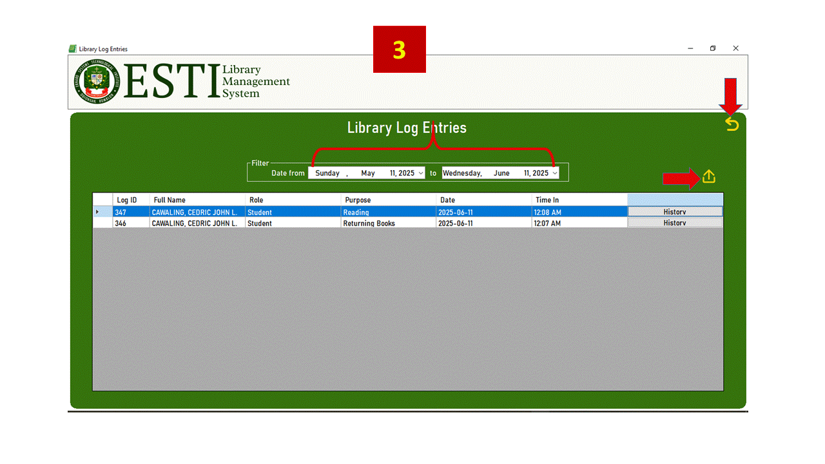

Figure 35.0 – Library Log Entries Screen

Figure 35.0 displays the Library Log Entries screen, which lists all visitor logs recorded through the Log Entry form. Each record includes the Log ID, Full Name, Role, Purpose, Date, and Time In. This allows the administrator to monitor attendance and review when and why users accessed the library.

The top section provides date range filters labeled “Date from” and “to”, which allow filtering records between two specific dates. Once selected, the list updates to show only the logs within that time frame.

On the right, the Back arrow returns the user to the previous screen. The Export icon triggers the generation of a detailed PDF report based on the filtered logs. This report includes the institution's logo and name, a date range header, and a structured table of log details formatted for printing or documentation purposes

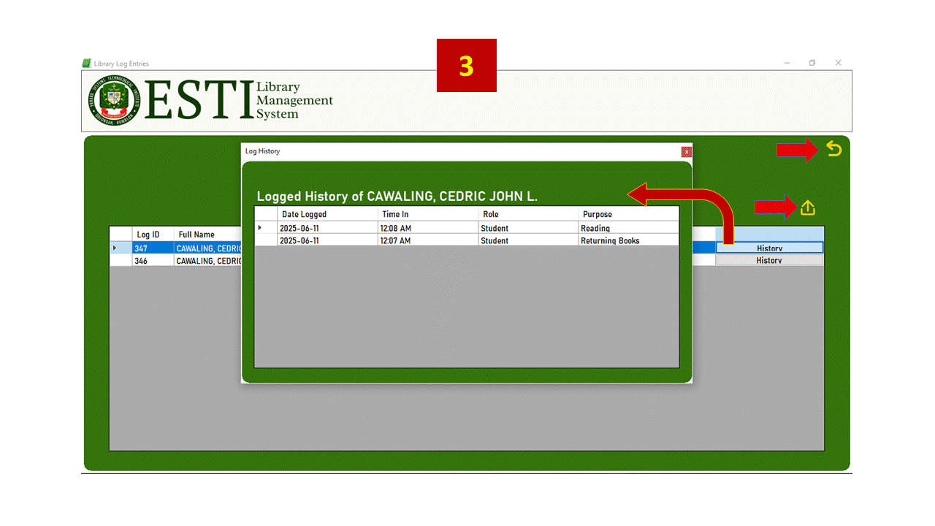Figure 36.0 – Log History

Figure 36.0 shows the Log History screen, which opens when the History button is clicked next to a user's name in the Library Log Entries list. This form displays a complete record of all past visits made by the selected individual. Each log entry includes the Date Logged, Time-in, Role, and Purpose.

The screen header clearly identifies whose history is being viewed, making it easier for administrators to verify repeated visits or review attendance patterns. This feature is useful for generating reports, confirming visit frequency, or investigating specific log details.

The Log History screen adds depth to the system’s tracking capability by allowing review of user-specific access records, all while maintaining a clean and focused layout.

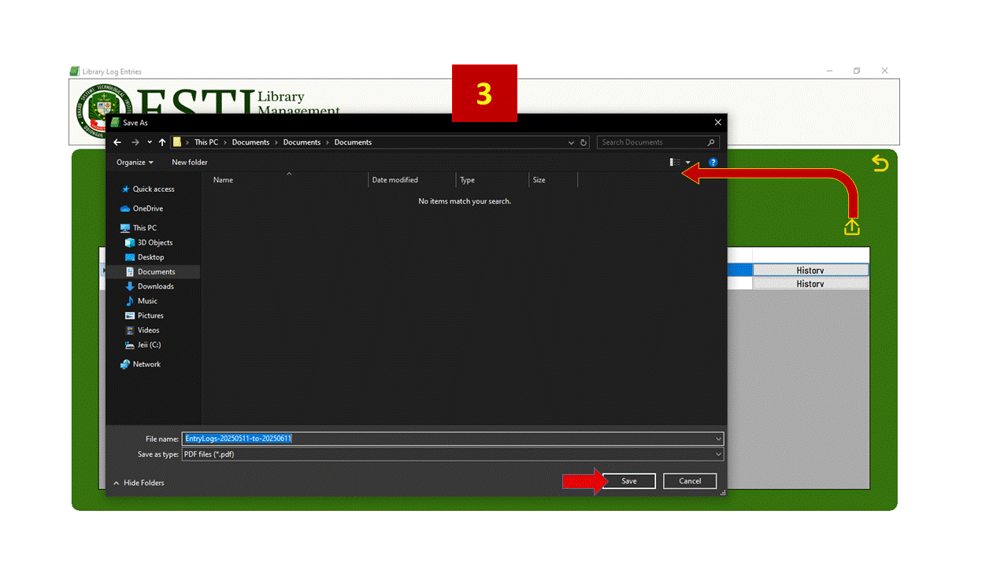

Figure 37.0 – Save As Dialog for Logs

Figure 37.0 shows the Save As dialog that appears when generating a log report from the Library Log Entries screen. After selecting a date range and clicking the Export icon, the system prompts the user to choose a save location and filename for the PDF. The default filename includes the selected date range, such as *EntryLogs-20250511-to-20250611.pdf*.

Once saved, the report includes the institution logo, name, report title, and the specified date range. Below that, a formatted table presents the Log ID, Full Name, Role, Purpose, and Date & Time In. This feature is designed for easy printing and official documentation of library usage record

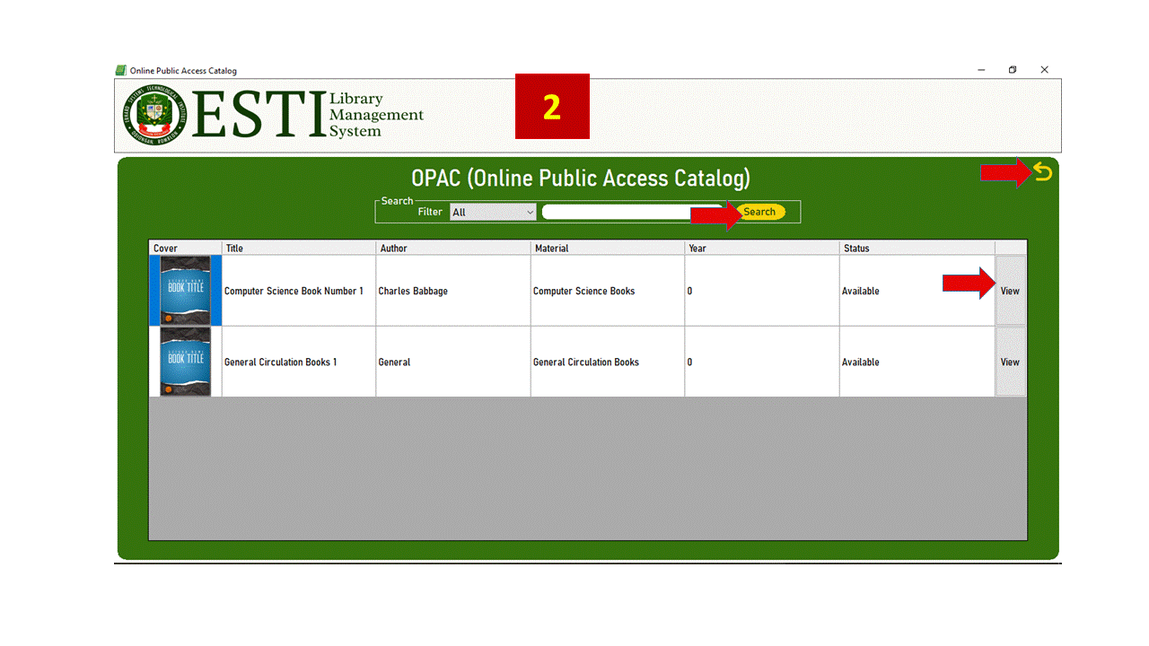Figure 38.0 – OPAC Screen

Figure 38.0 shows the OPAC (Online Public Access Catalog) screen, which allows users to browse the library's available books without logging in. Each book is displayed with its cover image, title, author, material type, year, and current status (Available or Borrowed). The status is determined based on the book's latest transaction record in the system.

Users can search for books using the search bar and filter results by material type using the dropdown list, which is dynamically populated from existing data in the system. After entering a keyword and selecting a filter, clicking the Search button updates the list to show only matching results.

To view more information about a specific book, users can click the View button, which opens a detailed book information window. This feature enhances public accessibility by allowing quick and easy access to book availability and details, supporting informed borrowing decisions

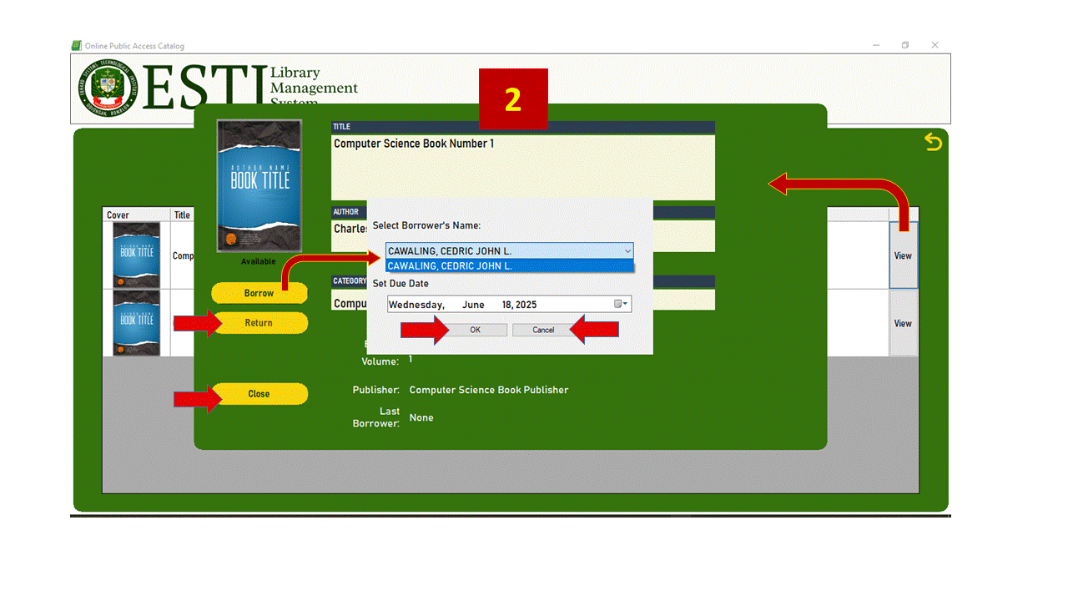Figure 39.0 – Book Details Interface

Figure 39.0 shows the Book Details interface, which opens when the View button is clicked from the OPAC screen. This window displays full book information including title, author, material type, edition, year, publisher, and the book's cover. It also shows the current status (e.g., Available or Borrowed) and the name of the most recent borrower.

Borrowing and returning actions are performed with administrator assistance. When the Borrow button is clicked, a pop-up window appears, allowing the admin to select a borrower’s name from a dropdown list populated from the Library Log Entries. The admin must also set a due date before confirming the transaction. Once submitted, the borrowing details are saved to the Transactions table, and the status is updated to “Borrowed.”

When the Return button is used, the system updates the same transaction record by adding the current date as the return date and changing the status to “Returned.” The Close button exits the view and returns to the OPAC list. All status updates and borrowing history are reflected in real time.

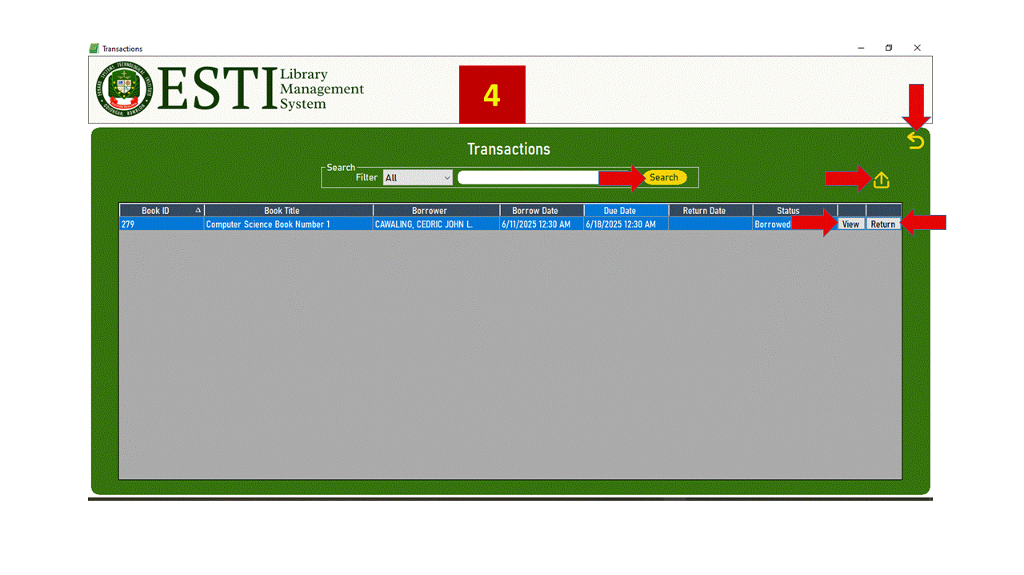

Figure 40.0 – Transactions Module

Figure 40.0 displays the Transactions module, which keeps track of all book borrowings and returns. Each row in the table shows the Book ID, Book Title, Borrower, Borrow Date, Due Date, Return Date, and Status (e.g., Borrowed or Returned). This screen helps the administrator monitor ongoing and completed transactions.

The user can narrow down the list using the Search bar and the Filter dropdown, which includes options such as *All*, *Borrowed*, *Returned*, and *Overdue*. Clicking the Search button refreshes the list based on the selected criteria.

Two actions are available per entry. Clicking the View button opens a detailed window that shows the transaction's full information, including the dates and borrower name. The Return button updates the transaction by marking it as returned, adding the current date to the *Return Date* field and updating the status to *Returned*. If the book has already been returned, the system will display a message to prevent duplicate actions.

An Export button at the top right allows the administrator to download the entire transaction list in Excel format. The Back button returns the user to the main dashboard.

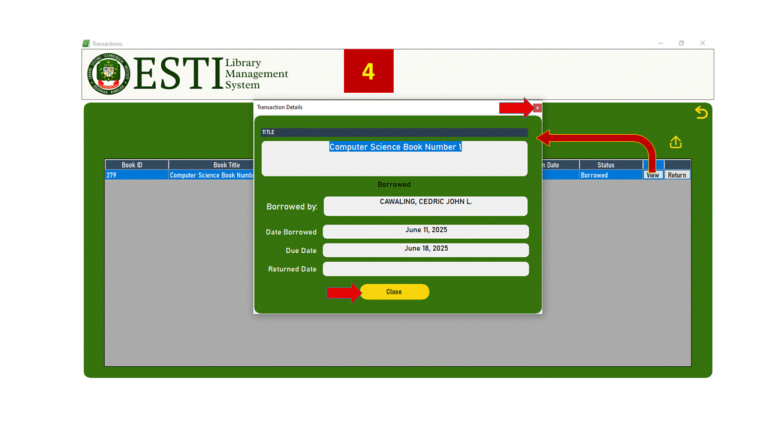 Figure 41.0 – Transaction Details Popup

Figure 41.0 shows the Transaction Details popup that appears when the View button is clicked from the Transactions screen. This window provides a summary of the selected transaction, including the Book Title, Borrower’s Name, Date Borrowed, Due Date, and Returned Date. The status (e.g., Borrowed or Returned) is also indicated.

This form is display-only and does not allow editing of fields. It helps the administrator quickly verify loan information without navigating away from the main transaction list. The Close button simply hides the panel and returns focus to the Transactions table.

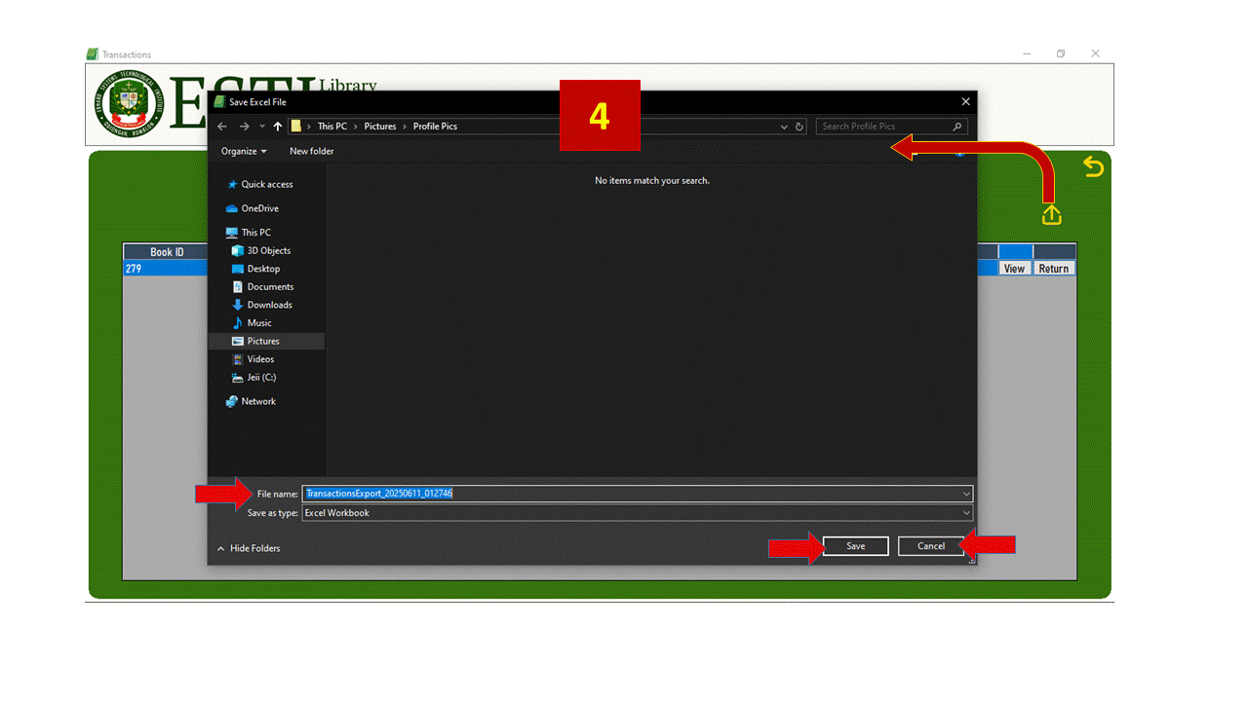 Figure 42.0 – Save File Dialog for Transactions

Figure 42.0 shows the Save File dialog that appears when generating a transaction report from the Transactions screen. After clicking the Export icon, the system opens this window, allowing the administrator to choose the location and filename for the exported file. By default, the filename includes a timestamp (e.g., TransactionsExport_20250611_012746.xlsx) to help uniquely identify each report.

The report is saved in Excel format and includes all visible fields: Book ID, Book Title, Borrower, Borrow Date, Due Date, Return Date, and Status. This exported file serves as an official record and can be used for printing, backup, or further analysis.

This feature helps the administrator generate structured documentation of borrowing and returning activity directly from the system.

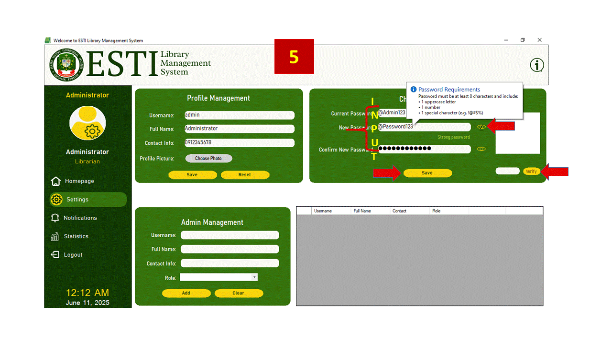

Figure 43.0 – Profile Management Panel 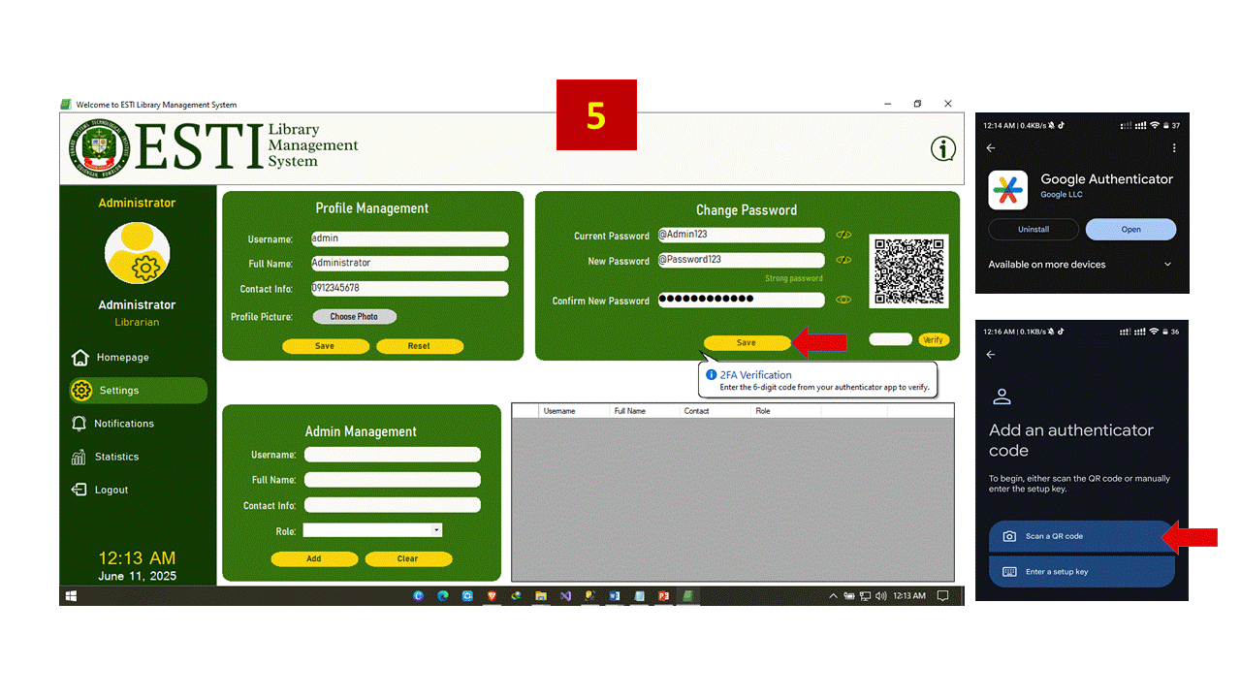 Figure 44.0 – Change Password with 2FA and Google Authenticator

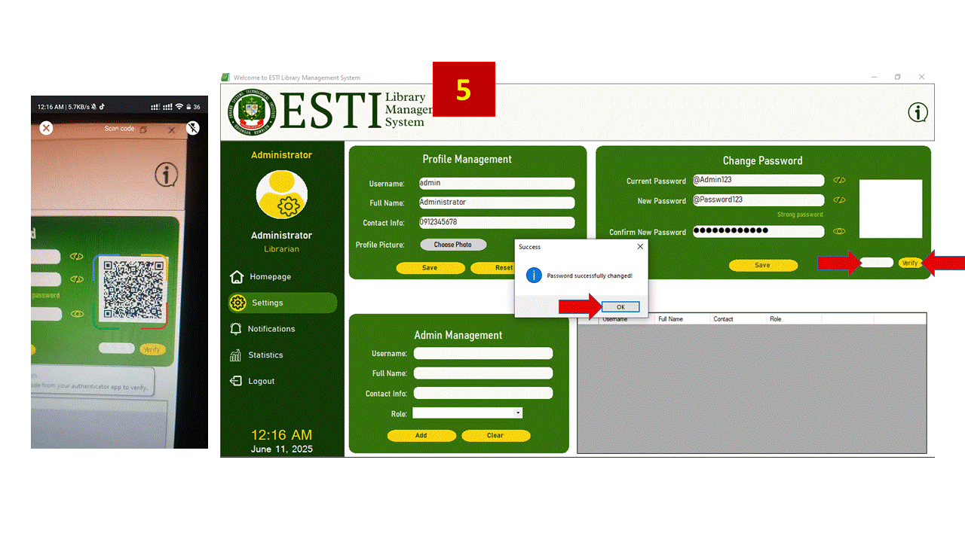

Figure 45.0 Change Password Confirmation

Figures 43.0 to 45.0 show the full process of changing an administrator’s password with built-in two-factor authentication (2FA). The panel is located under Settings, and requires the user to input their current password, a new password, and a confirmation. A password strength label displays whether the entered password is weak, medium, or strong, and only enables saving when the password is rated strong.

After validating the password fields, the system generates a time-based one-time password (TOTP) secret and a corresponding QR code. This QR code can be scanned using apps such as Google Authenticator. Once scanned, the app continuously generates 6-digit codes linked to the user’s account.

The user must enter a valid OTP within a limited time window (90 seconds), after which the code expires and must be regenerated. When the Verify button is clicked and the OTP is valid, the password is successfully updated in the system and a confirmation message appears. If the code is invalid or expired, the process prompts the user to retry. This entire process ensures that only the rightful account holder can change the password, combining strong credential policies with modern mobile-based 2FA protection.

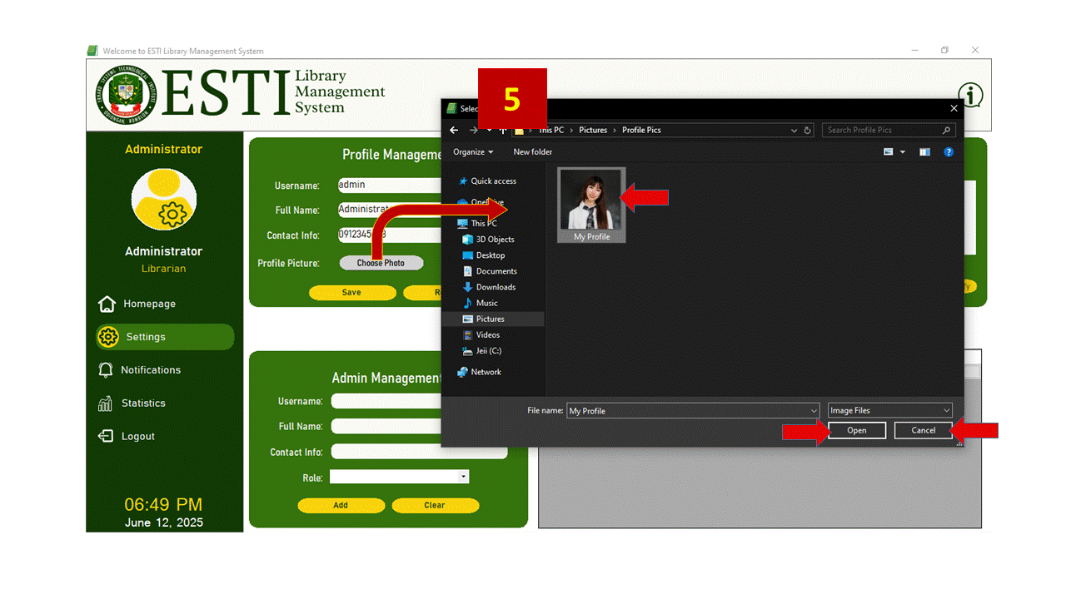

Figure 46.0 Choose Admin Profile Photo

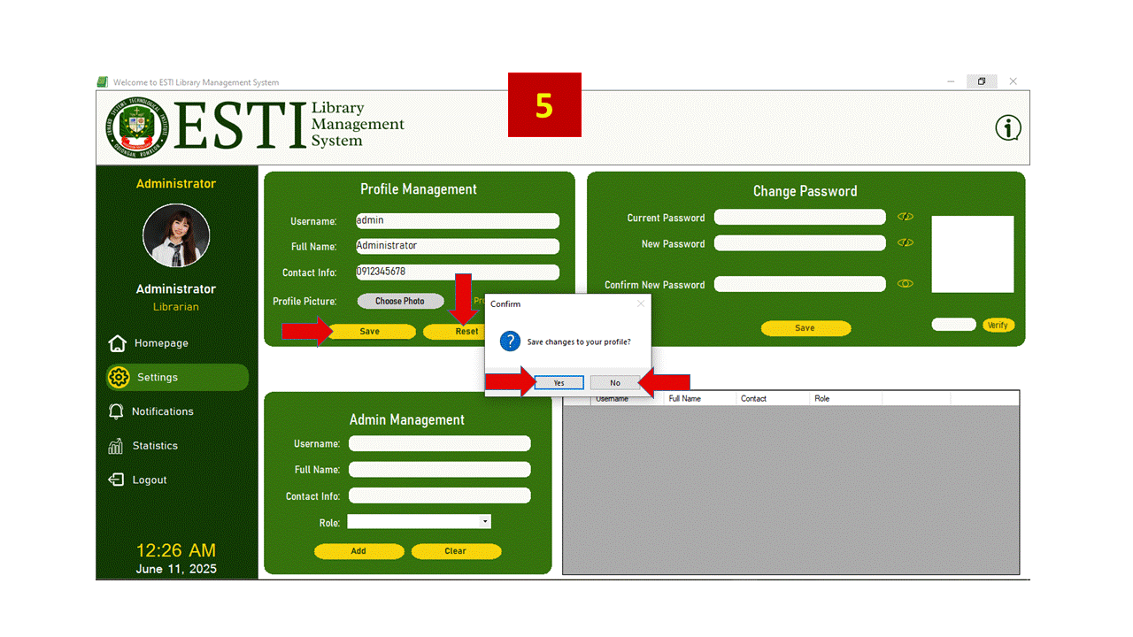

Figure 47.0 Update Admin Details

Figure 46.0 and 47.0 shows the Profile Management panel where the administrator can update their Full Name, Contact Info, and Profile Picture. These fields are editable and reflect the active account's stored details. To update the profile photo, the user clicks the Choose Photo button, which opens a file dialog for selecting an image file. Once selected, the image is displayed immediately in the profile section on the sidebar.

After making changes, the user clicks Save to apply updates. A confirmation dialog appears to verify the action. Clicking Yes commits the changes, while No cancels the operation. The Reset button clears unsaved changes, reverting the form to its original state.

This panel helps personalize and maintain accurate administrator records and enhances usability by visually identifying the active user.

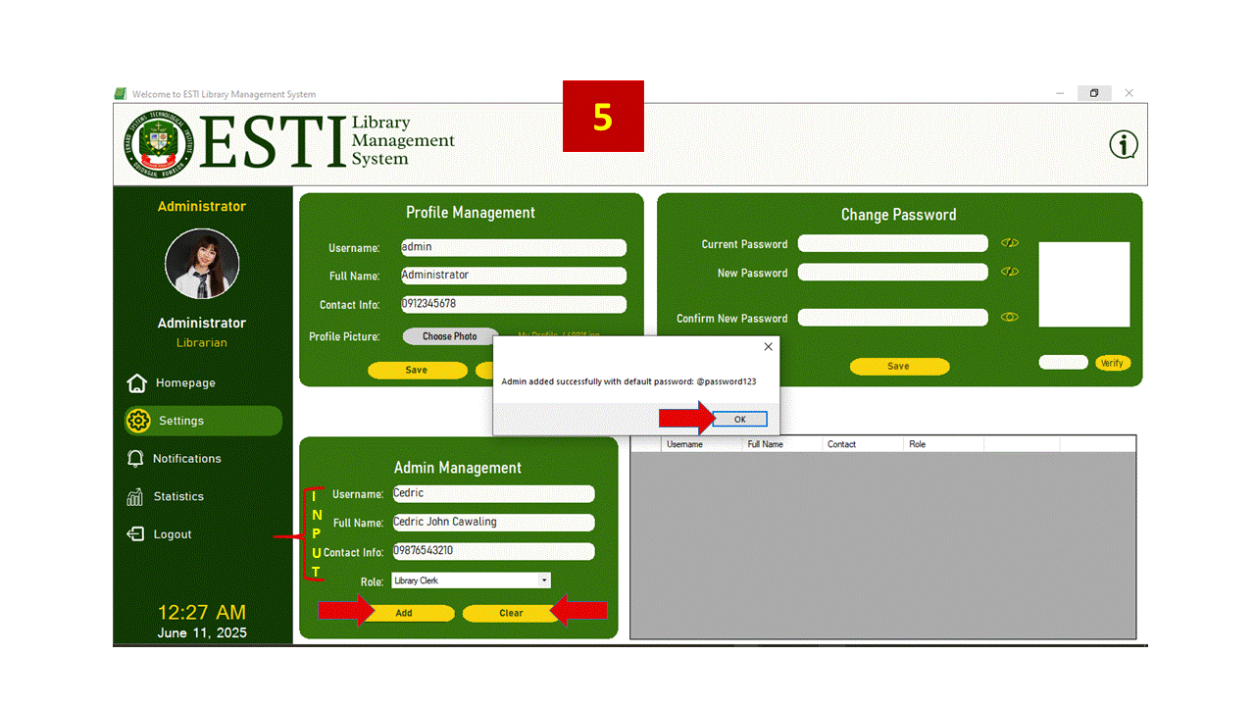

Figure 48.0 Add Admin Accounts

Figure 48.0 presents the Admin Management panel, which allows the current administrator to add new admin users into the system. To create a new account, the administrator must fill in the Username, Full Name, Contact Info, and select a Role from the dropdown list. Roles may include classifications such as Librarian or Library Clerk, depending on access level.

Once all fields are filled, clicking Add will register the new account in the system. A confirmation message is then shown, stating that the account has been created using the default password *“@password123*”. This password is intended to be temporary and should be updated by the new user upon first login.

The Clear button resets all input fields, allowing for quick entry of multiple accounts in succession. This panel supports controlled access to system features and ensures that each admin user has a unique login tied to their role and contact details.

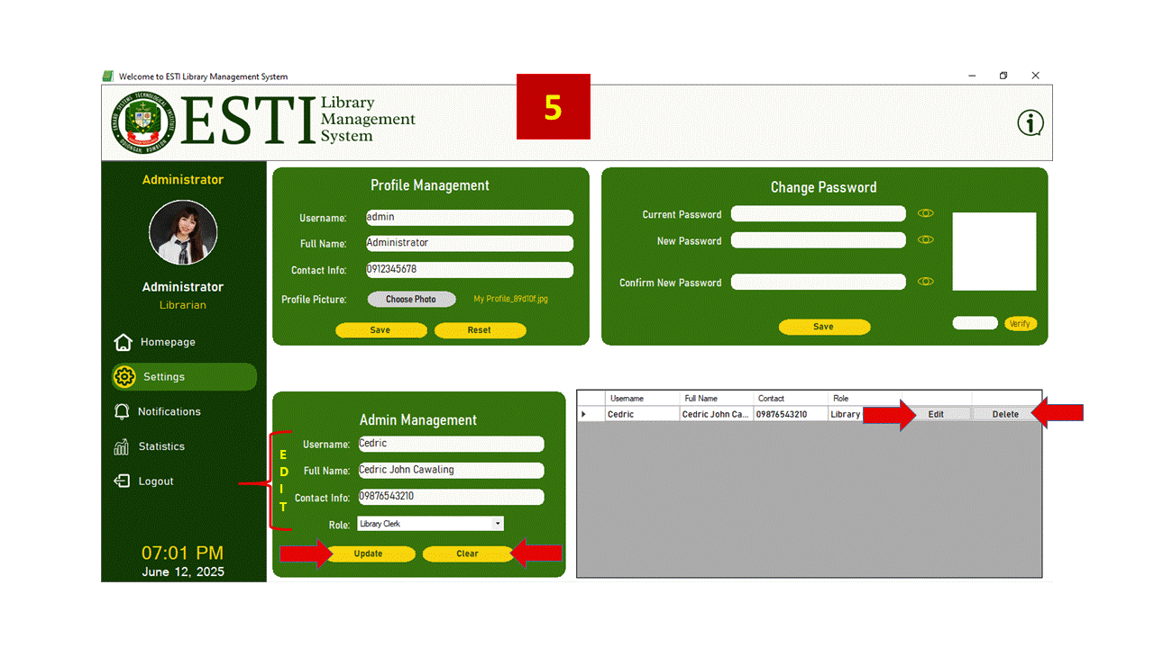Figure 49.0 Edit/Delete Admin Account

Figure 49.0 shows the interactive features of Admin table in the Admin Management panel. Each row displays registered administrator accounts, including Username, Full Name, Contact Info, and Role. At the far right of each row are the Edit and Delete buttons.

Clicking Edit loads the selected admin’s details into the input fields below. The Add button changes to Update, allowing the administrator to modify the user's information. After editing, clicking Update saves the changes and refreshes the list.

Clicking Delete prompts a confirmation message before permanently removing the account from the database. This prevents accidental deletions and ensures that account removal is intentional.

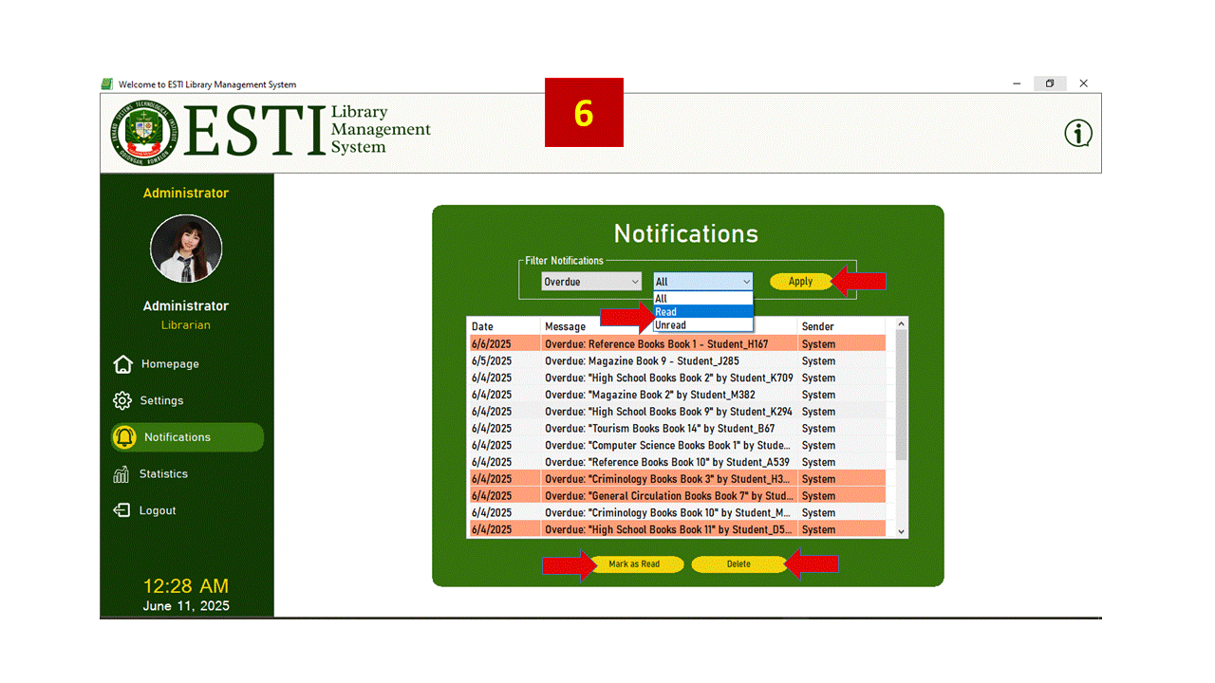Figure 50.0 Notifications Panel

Figure 50.0 presents the Notifications panel, which displays system-generated messages—primarily alerts about overdue books. Each entry in the list shows the Date, Message, and Sender. These alerts help administrators monitor user responsibilities and track system activity.

At the top, administrators can filter notifications by type (e.g., Overdue) and status (All, Read, or Unread) using dropdown menus. After selecting filter values, clicking Apply refreshes the list accordingly.

Users can select specific notifications and take action using the Mark as Read or Delete buttons. These help manage the visibility and relevance of alerts by clearing old or acknowledged items.

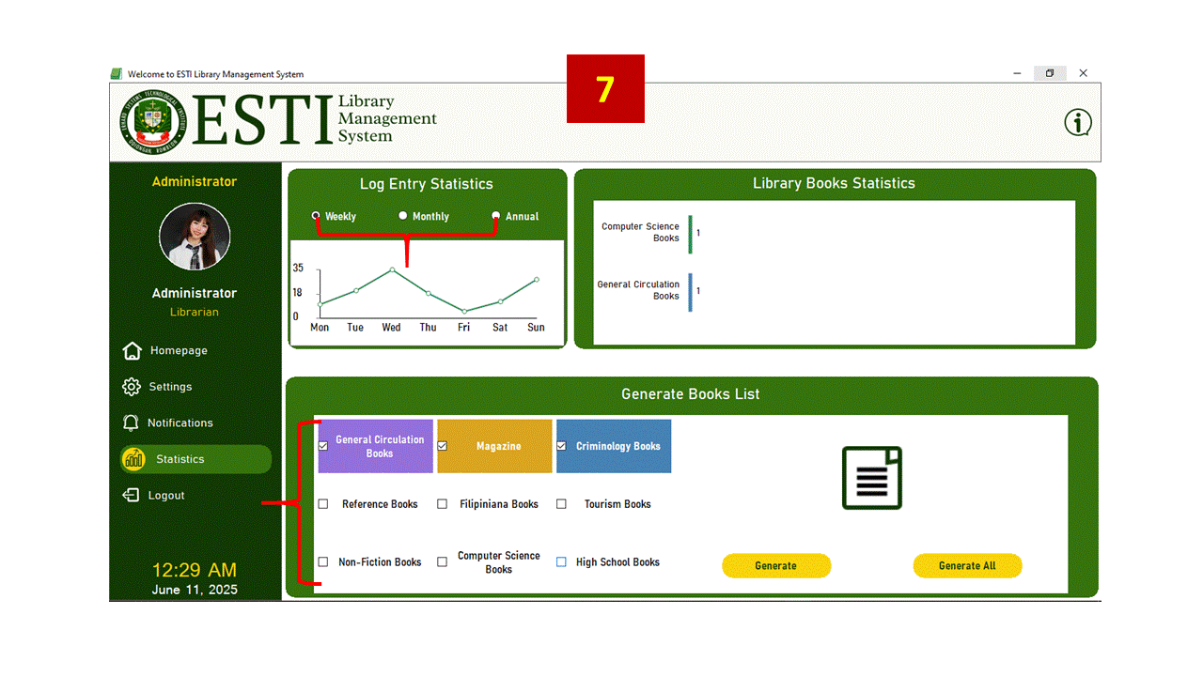 Figure 51.0 Statistics Panel

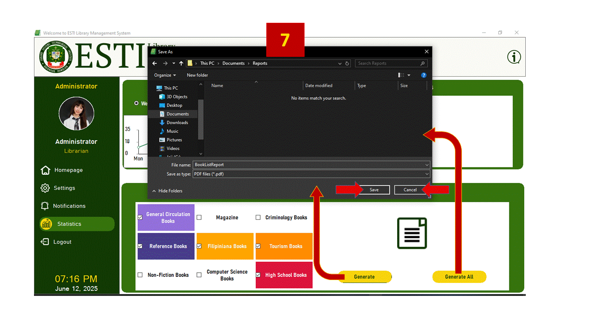

Figure 52.0 Statistics Panel – Generate Book Report

Figure 51.0 and 52.0 displays the Statistics panel, which provides a visual summary of system usage and library inventory. The panel consists of three main sections: Log Entry Statistics, Library Books Statistics, and Generate Books List.

In the upper left section, Log Entry Statistics shows a line graph that visualizes user visit frequency over time. The graph can be switched between Weekly, Monthly, or Annual views using radio buttons. This allows the administrator to track patterns and peak usage days.

On the right, the Library Books Statistics bar chart displays a count of books grouped by material type, such as General Circulation Books or Computer Science Books. This helps the librarian assess collection distribution and inventory strength.

The lower panel, Generate Books List, allows the user to select one or multiple book categories and click Generate to create a filtered list. The Generate All button creates a complete report across all categories. This supports easy documentation, catalog review, and printed reports for inventory purposes.

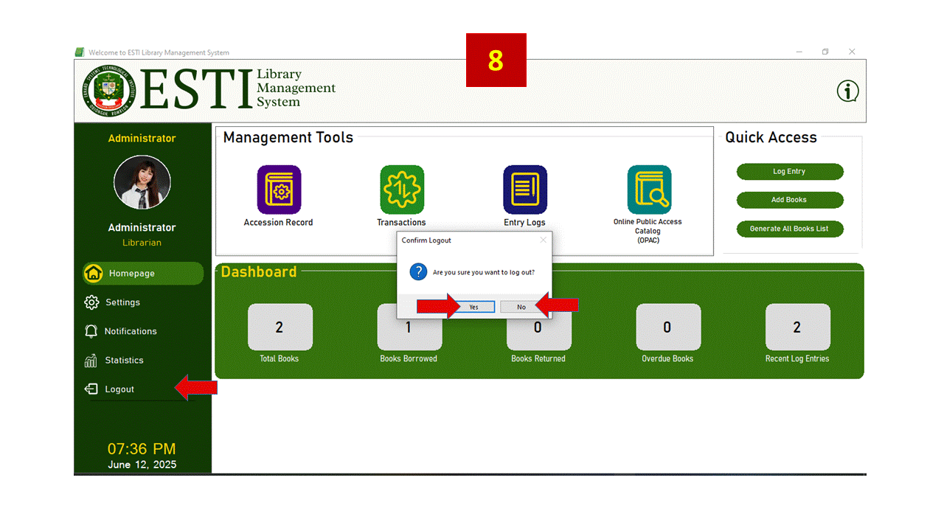

Figure 53.0 Logout Button

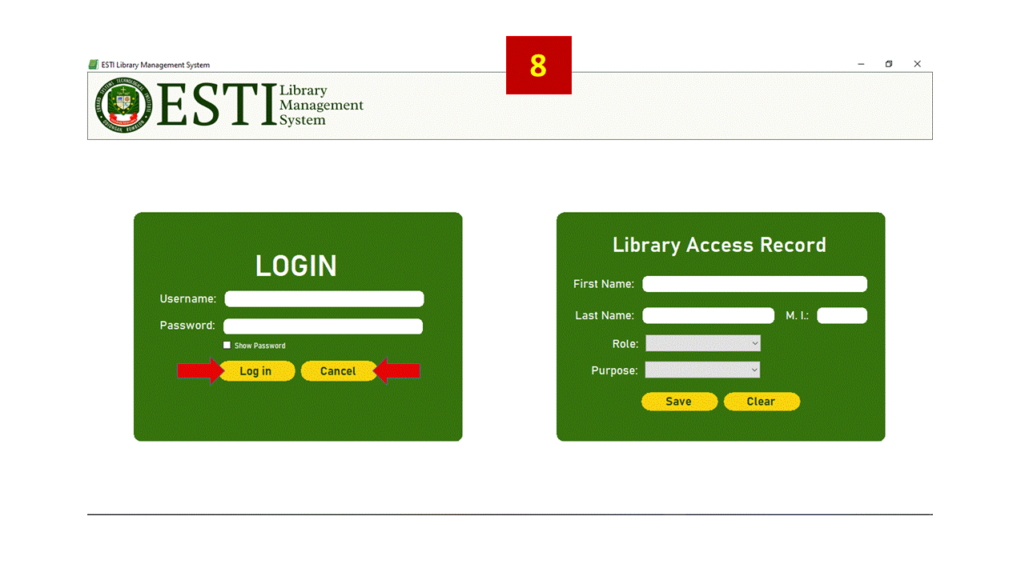

Figure 54.0 Login/Log Entry Form

Figure 53.0 show the Logout functionality is triggered by clicking the Logout button on the sidebar of the main form. This executes a confirmation dialog asking the user to confirm their intention to exit. If confirmed, closes the current session, and returns the user to the Login screen. This controlled flow ensures clean session handling and prevents users from accidentally closing their session without intending to.

Figure 54.0 shows the Login interface and the Library Access Record panel, both located on the system’s start screen. The Login section is for registered administrators who must enter a valid username and password to access the system. The password field uses a masked character (●) by default, with a Show Password checkbox available for visibility. Upon clicking Log in, the system checks credentials by comparing the hashed password against stored values in the database. If the login is invalid, an error message is displayed. If Cancel button closes the whole system.

If the login is successful but the user is still using the default password (@password123), the system prompts them to change it before continuing. If they agree, the Set Password form opens. If they decline or close the form without completing the update, access is denied and they are returned to the login screen. This ensures that all administrators secure their accounts immediately after creation. Upon successful update, user details and optional profile picture paths are loaded into memory, and the user is then directed to the main dashboard.

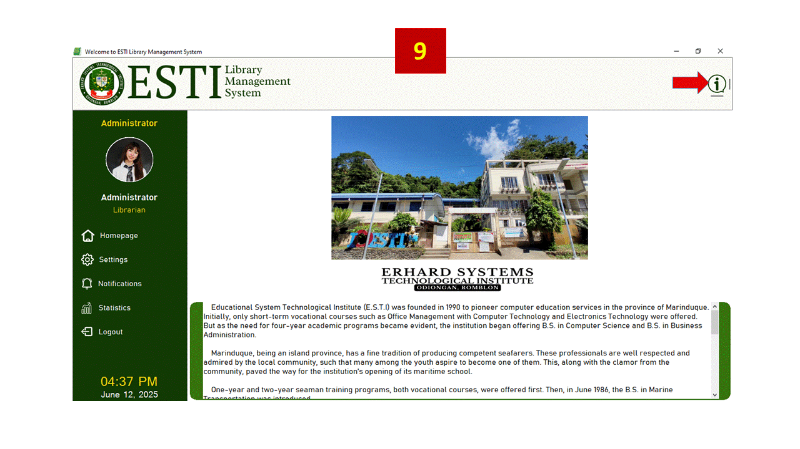Figure 55.0 About Panel with School History

Figure 55.0 shows the About Panel, which appears when the user clicks the small information icon (ⓘ) at the top right corner of the screen. This section provides background information about Erhard Systems Technological Institute (E.S.T.I.), including its history, academic programs, and community contributions. It helps users understand the school’s identity and purpose for developing the Library Management System. At the top of the panel, a picture of the school is shown, followed by a block of text that tells the History of E.S.T.I.

**Project Capabilities and Limitations**

The Library Management System developed for Erhard Systems Technological Institute (E.S.T.I.) is designed to help administrators efficiently manage books, records, and library activity. It has the following capabilities:

1. Secures access through a login system that restricts usage to registered administrators only;
2. Provides an Admin Management panel to add, edit, and delete admin accounts with role assignment and password protection;
3. Includes a Profile Management module for updating administrator details;
4. Supports complete Book Management, allowing admins to register, update, or remove books, including attaching cover photos and categorizing by material type;
5. Displays book details in a separate view, including real-time availability and last borrower info;
6. Enables borrowing and returning of books with automatic status tracking and due date management;
7. Tracks overdue books and displays them in a dedicated notification panel for admin action;
8. Facilitates visitor tracking through the Library Log Entry module, with safeguards against duplicate entries per day;
9. Provides a visual dashboard with summary statistics for visits, book status, and borrowing activities;
10. Generates printable reports (PDF/Excel) for books, logs, and transactions with school branding and formatting;
11. Offers a searchable OPAC module where book titles and basic information can be reviewed;
12. Includes activity filtering features for books and logs based on material type and keyword;
13. Supports graphical charts showing most borrowed books, active visitors, and weekly borrowing trends.

The following are the key limitations of the Library Management System:

1. The system operates offline and cannot be accessed remotely or via a web browser;
2. Only administrators can log in—there is no support for separate librarian or student accounts;
3. Multi-user access is limited without configuring a shared database server environment;
4. No built-in feature exists for automatic data backup or recovery;
5. The notification system is limited to visual alerts—no email or sound notifications;
6. Fines and penalties for overdue books are not calculated or enforced automatically.

**Project Test Results**

The developed Library Management System (LMS) was distributed to thirty (30) respondents. They were comprised of twenty (20) students and ten (10) ESTI employees. The features, capabilities, and limitations of the system were explained to make sure that the LMS would be evaluated accordingly. Moreover, the evaluation instrument was also explained.

The evaluation instrument was based on the LMS Evaluation Tool for Software and was categorized into five criteria: Functionality, Usability, Reliability, Performance, and Supportability.

Each of the criterions in the instrument provided a scale of 1-5; 5 being the highest and 1 being the lowest. The result of the evaluation of the Library Management System came up with the mark of Strongly Agree, with an overall mean score of 4.16. Among the 5 components, supportability got the highest mean score of 4.36, performance ranked second with a mean score of 4.20, reliability ranked third with the mean score of 4.13, functionality ranked fourth with the mean score of 4.158, and usability got the lowest mean score of 3.956. Refer to Table 5 for the summary of the evaluation results.

**Table 1**

Summary of Evaluation Results.

|  |  |  |
| --- | --- | --- |
| Criteria | Mean (X) | Descriptive Rating |
| A. Functionality | 4.20 | Strongly Agree |
| B. Usability | 4.00 | Strongly Agree |
| C. Reliability | 4.13 | Strongly Agree |
| D. Performance | 4.20 | Strongly Agree |
| E. Supportability | 4.36 | Strongly Agree |
| Overall Mean (X) | 4.16 | Strongly Agree |

In terms of Functionality, the evaluators gave a descriptive rating of Strongly Agree with a mean score of 4.20. This means that the system fulfilled all its required features and specifications effectively.

In terms of Usability, the evaluators gave a descriptive rating of Strongly Agree with a mean score of 4.00. This indicates that the system was generally easy to use and understand.

In terms of Reliability, the evaluators gave a descriptive rating of Strongly Agree with a mean score of 4.13. This demonstrates that the system operated consistently and produced accurate outputs.

In terms of Performance, the evaluators gave a descriptive rating of Strongly Agree with a mean score of 4.20. This means the system responded efficiently to user interactions and system tasks.

In terms of Supportability, the evaluators gave a descriptive rating of Strongly Agree with a mean score of 4.36. This suggests that the system is well-documented, configurable, and easy to maintain.

Chapter 5

**SUMMARY, CONCLUSION, AND RECOMMENDATIONS**

This chapter presents the summary of findings, conclusion and recommendations based on the results of the study.

**Summary of Findings**

The Library Management System (LMS) for Erhard Systems Technological Institute is a desktop-based software developed to optimize library operations. It includes modules for book management, user authentication with OTP, borrow and return tracking, real-time statistics, overdue notifications, and secure PDF/Excel reporting.

The project was evaluated using the LMS Evaluation Instrument based on the FURPS model, and the results are as follows:

1. Functionality. The evaluators gave a descriptive rating of Strongly Agree with an average mean score of 4.2. This indicates the system met its intended core functions and features.

2. Usability. The evaluators gave a descriptive rating of Strongly Agree with a mean score of 4.00. This confirms the system is user-friendly and easily navigable.

3. Reliability. The evaluators gave a descriptive rating of Strongly Agree with a mean score of 4.13, suggesting consistent and dependable operation.

4. Performance. The evaluators gave a descriptive rating of Strongly Agree with a mean score of 4.20, reflecting responsive performance during tasks like searching and authentication.

5. Supportability. The evaluators gave a descriptive rating of Strongly Agree with a mean score of 4.36, indicating the system can be easily updated and is well-documented.

**Conclusions**

1. The researcher was able to design a Library Management System that met the required specifications of the institution and improved existing library operations.

2. The system was successfully developed using VB.NET, Microsoft SQL Server, and tools such as iTextSharp, QRCoder, and SSMS, with secure login, OTP verification, and modular architecture.

3. Based on user evaluation, the LMS was rated Strongly Agree overall, with a general mean of 4.18, confirming that it met the performance expectations for school library automation.

**Recommendations**

Based on the findings, the following recommendations were formulated:

1. Enhancement can be made on the following:

* 1. The system can be enhanced with a web-based version to support remote access.
  2. Integration of an automatic backup feature for data security.
  3. Addition of penalty computation for overdue returns and support for email notifications.
  4. Editable generated reports for more precise data reporting
  5. User friendly user interface using smaller fonts and neutral colors
  6. More comprehensible buttons and label
  7. Flag books reaching their 5th year of publication and changes their circulation status from "General Collection" to "Reference"
  8. Integration of web search for OPAC to widen book coverage
  9. Web search for Accession, to automatically input book information in Add books using one click.
  10. Develop a web-based application similar to this LMS

**BIBLIOGRAPHY**

**Peer-Reviewed Journals / Academic Articles**

Iwayemi, A., & Adebayo, S.O. (2019). Development of a Robust Library Management System. International Journal of Computer Applications.

Patidar, D., Maheshwari, H., & Garg, I. (2024). Library Management System. International Journal of Information Technology and Computer Engineering, 4, 9–13. https://doi.org/10.55529/ijitc.43.9.13

Singh, A., & Kaur, H. (2019). Digital transformation of academic libraries: A study of usage logs and access control. International Journal of Library Science, 18(2), 65–72.

Bales, S., & Leffler, J. (2020). The evolving role of academic librarians in digital environments. Journal of Academic Librarianship, 46(4), 102154. https://doi.org/10.1016/j.acalib.2020.102154

Smith, R., & Wiggins, B. (2018). Security and privacy in library systems: Approaches and practices. Information Technology and Libraries, 37(4), 56–67. https://doi.org/10.6017/ital.v37i4.10659

Krishna, V., & Sharma, A. (2020). Database administration and security in SQL Server Management Studio. International Journal of Computer Applications, 176(14), 1–7. https://doi.org/10.5120/ijca2020919939

Rahimi, S., & Haug, J. (2019). Data management and development using SQL Server tools. Journal of Systems and Software Engineering, 32(1), 45–54.

Owen, D. (2016). The role of usage data in libraries: Improving service through data. Library Management, 37(1/2), 78–91. https://doi.org/10.1108/LM-06-2015-0040

Kettunen, J. (2021). Information management in academic libraries: Emphasizing documentation and reporting. Library Review, 70(5), 453–465. https://doi.org/10.1108/LR-07-2020-0105

Shafack, R., & Takam, D. (2018). The role of automated reports in academic library management. International Journal of Library and Information Science, 10(3), 21–29. https://doi.org/10.5897/IJLIS2017.0803

Forsell, M., et al. (2021). Performance and programmability comparison of the thick control flow architecture and current multicore processors. Journal of Supercomputing, 78(3), 3152–3183. https://doi.org/10.1007/s11227-021-03985-0

Teslyuk, V., et al. (2024). Preliminary Estimation for Software Development Projects. Applied System Innovation, 7(3), 34. https://doi.org/10.3390/asi7030034

**Books and Book Chapters**

Rubin, R. E., & Rubin, R. G. (2020). Foundations of Library and Information Science (5th ed.). American Library Association.

Rubin, R. E. (2017). Foundations of Library and Information Science (4th ed.). ALA Neal-Schuman.

Burke, J. J., & Tumbleson, B. E. (2016). Chapter 1. LMS Embedded Librarianship and the Educational Role of Librarians. Library Technology Reports.

Olanlokun, S.O., & Salisu, M.T. (1993). Understanding the Library: A Handbook on Library Use. University Press, Lagos.

Bishop, M. (2003). Computer Security: Art and Science. Addison-Wesley.

**Government or Institutional Guidelines**

Commission on Higher Education (CHED). (2014). CHED Memorandum Order No. 1, Series of 2014: Policies and Guidelines on Libraries and Librarianship in Higher Education Institutions. https://ched.gov.ph

International Organization for Standardization. (2015). ISO 9001:2015 – Quality management systems – Requirements. https://www.iso.org/standard/62085.html

American Library Association. (2019). Core values of librarianship. https://www.ala.org/advocacy/intfreedom/corevalues

**Theses and Dissertations**

Valenti, E. (2015). The state of library management systems [Thesis]. https://www.studocu.com/ph/document/um-tagum-college/information-technology/foreign-related-literature-title-the-sta/86380329

**Websites, Blogs, and Tech Articles**

Wikipedia contributors. (2024, June 18). Visual Studio. Wikipedia. https://en.wikipedia.org/wiki/Visual_Studio#Features

Lutkevich, B., & Wigmore, I. (2021). System software. WhatIs. https://www.techtarget.com/whatis/definition/system-software

GeeksforGeeks. (2024). Library Management System Project Software development. https://www.geeksforgeeks.org/library-management-system/

Satish. (2023). Why need a library management system? Algorhythms. https://slimkm.com/news-articles/why-need-a-library-management-system/

Kanade, V. (2023). Visual Basic Features and Applications. SpiceWorks. https://www.spiceworks.com/tech/devops/articles/what-is-visual-basic/

Idoko, N. (2023). How much RAM do you need for coding? Learn Coding USA. https://learncodingusa.com/how-much-ram-for-coding/

Parthasarathi, R. (n.d.). Case Studies of Multicore Architectures I. https://www.cs.umd.edu/~meesh/411/CA-online/chapter/case-studies-of-multicore-architectures-i/index.html

Fisher, B. (2020). Laptop use in class: Effects on Learning and Attention. Center for Teaching and Learning. https://ctl.wustl.edu/laptop-use-effects-learning-attention/

Marinaki, A. (2023). Librarian job description. Workable. https://resources.workable.com/librarian-job-description

CDS/ISIS & iLib software. (2019). https://mainlib.upd.edu.ph/cds-isis-ilib-software/

Anbarasan. (2017). Library Management System. SourceForge. https://sourceforge.net/projects/librarymanagementsystemdotnet/

Research Guides. The Library of Congress Card Catalog: How to Use the Card Catalog. https://guides.loc.gov/card-catalog/using-the-card-catalog

**APPENDIX A**

**DEVELOPMENT OF LMS: LIBRARY MANAGEMENT SYSTEM OF ERHARD SYSTEMS TECHNOLOGICAL INSTITUTE**

**COMPUTER SCIENCE THESIS PROJECT SOFTWARE EVALUATION**

**Instructions:** Based on your experience with the prototype, please evaluate the ESTI Library Management System (LMS). For each item, place a checkmark (√) under the numerical rating that best reflects your agreement or satisfaction.

*Rating Scale:*

5 - Very Strongly Agree

4 - Strongly Agree

3 - Agree

2 - Disagree

1. Strongly Disagree

**PART I. Respondent Information**

|  |  |
| --- | --- |
| Name (Optional): | |
| Position: *(please check the appropriate box:)* | * ESTI Employee ☐ ESTI Student ☐ Others: ___________________ |

**PART II. Library Management System (LMS) Evaluation Criteria**

|  |  |  |  |  |  |
| --- | --- | --- | --- | --- | --- |
| **INDICATORS** | 5 | 4 | 3 | 2 | 1 |
| 1. **Functionality** |  |  |  |  |  |
| 1. The system implements book cataloging, user management, book borrowing and returning, and overdue tracking. |  |  |  |  |  |
| 1. The system provides user authentication and role-based access control (e.g., librarian, assistant librarian, library clerk, student). |  |  |  |  |  |
| 1. The system handles data correctly (e.g., inventory updates and due date calculations) |  |  |  |  |  |
| 4. The system includes an OPAC module that enables users to search for and view books by material type. |  |  |  |  |  |
| **B. Usability** |  |  |  |  |  |
| 1. **Ease of operation:** The system is easy to understand and operate, and it responds quickly to tasks performed by the user (e.g., a librarian, assistant librarian, library clerk, student). |  |  |  |  |  |
| 2. **User-friendly:** The system’s interface layout is clear, visually appealing, and well-organized. |  |  |  |  |  |
| 3. The system is error-free during the execution of user tasks. |  |  |  |  |  |
| **C. Reliability** |  |  |  |  |  |
| 1. The system is fully operational. |  |  |  |  |  |
| 2. The system operates reliably without unexpected errors. |  |  |  |  |  |
| 3. The system maintains accurate and consistent records during transactions. |  |  |  |  |  |
| **D. Performance** |  |  |  |  |  |
| 1. The system responds quickly during book searches, log-in or authentication processes, and other library transactions. |  |  |  |  |  |
| 2. The system is efficient at handling library transactions. |  |  |  |  |  |
| **E. Supportability** |  |  |  |  |  |
| 1. The system's patches and upgrades are easy to apply. |  |  |  |  |  |
| 2. The system’s manuals for users, administrators, and developers are available and easy to understand. |  |  |  |  |  |
| 3. The system's settings (e.g., borrowing limits, user roles) can be adjusted without modifying the code. |  |  |  |  |  |

**PART III. Comments and Suggestions**

**Instructions:** Please provide any feedback, suggestions, or observations to help improve the system.

________________________________________________________________________________

________________________________________________________________________________

________________________________________________________________________________

________________________________________________________________________________

**APPENDIX B**

**GANTT CHART**

**Table 2**

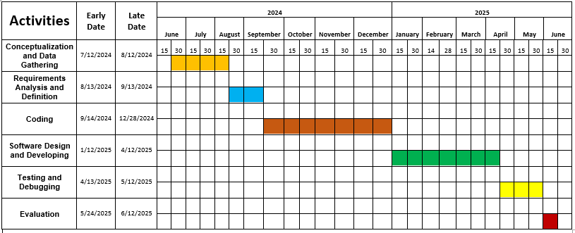Summary of Activities

**APPENDIX C**

**Table 3**

Evaluation Results of the Evaluators

**APPENDIX D**

**REQUEST LETTER**

Erhard Systems Technological Institute

Poctoy Odiongan, Romblon

June 10, 2025

Madam / Sir,

Good Day!

I am a graduating students of Erhard Systems Technological Institute taking up Bachelor of Science in Computer Science. I am in the process of gathering data through questionnaires that will be used in our study entitled: LMS: Library Management System of Erhard Systems Technological Institute.

We would like to request your time in answering the questions honestly. Rest assured that all the data gathered will be treated utmost confidentially and will be used for academic purpose only.

Thank you and God bless.

**The Researcher,**

Cedric John L. Cawaling

Avegail L. Manggol, MIT, LPT

**The Research Adviser**

**APPENDIX E**

**Table 4**

Total Budgetary Requirements

|  |  |
| --- | --- |
| **PARTICULARS** | **AMOUNT** |
|  |  |
| **1. Personal Services (PS)** |  |
| 1.1 Printing | 5000 |
| 1.2 Internet Connection | 3500 |
|  |  |
| **Total Personal Services** | **8500** |
|  |  |
| **2. Maintenance and other operating expenses (MOOE)** |  |
| 2.1 Travel Expenses | 5000 |
| 2.2 Other Services | 5000 |
|  |  |
| **Total Maintenance and other operating expenses** | 10000 |
|  |  |
| **TOTAL BUDGET** | **18500** |

**APPENDIX F**

*Software Installation*

System Requirement

1. Operating System Requirement: Windows 10 or higher.

2. Intel(R) Core(TM) i3-4005U CPU @ 1.70GHz 4.00 GB RAM 64-bit operating system, x64-based processor

3. SQL Server

4. SQL Server Management Studio to Manage importing the Database and Schema.

*Admin Registration*

1. After the app is initialized either from clicking the Icon from windows start or from the desktop shortcut, it will need to have an admin account created first.

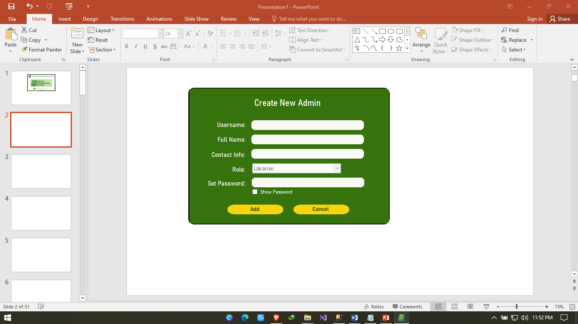

2. The admin should enter their credentials and add it to the database in order to access the system.

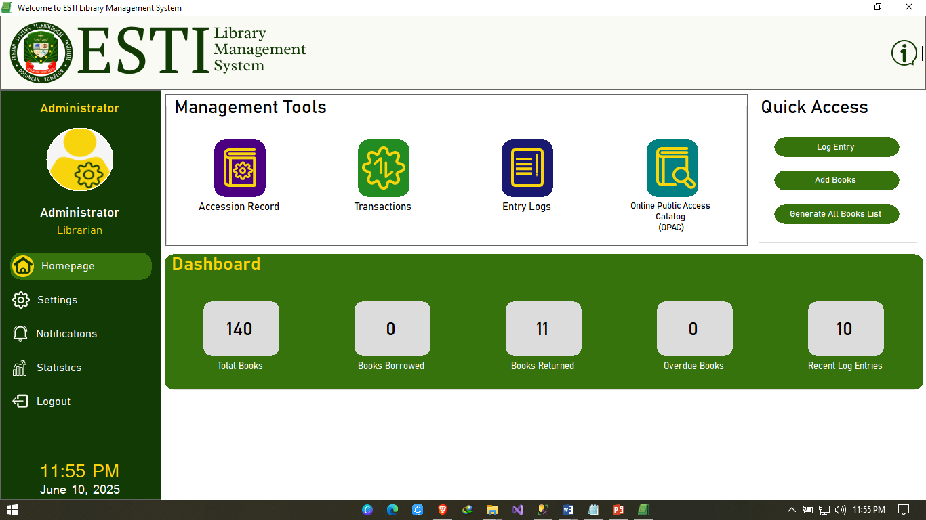

*Using Accession Record Feature*

1. Use Add Books button to add new books and use Edit button to alter existing book details and use Delete to remove a book.

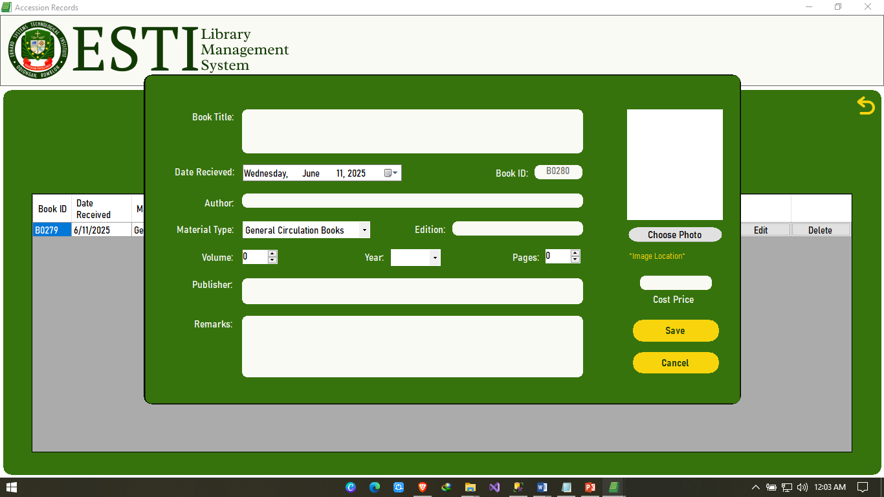

*Using OPAC Feature*

1. The user can click the View button to see the full details of a book. In there the user can either borrow/return a book depending on the availability. Then set the borrower name and due date to return a book.

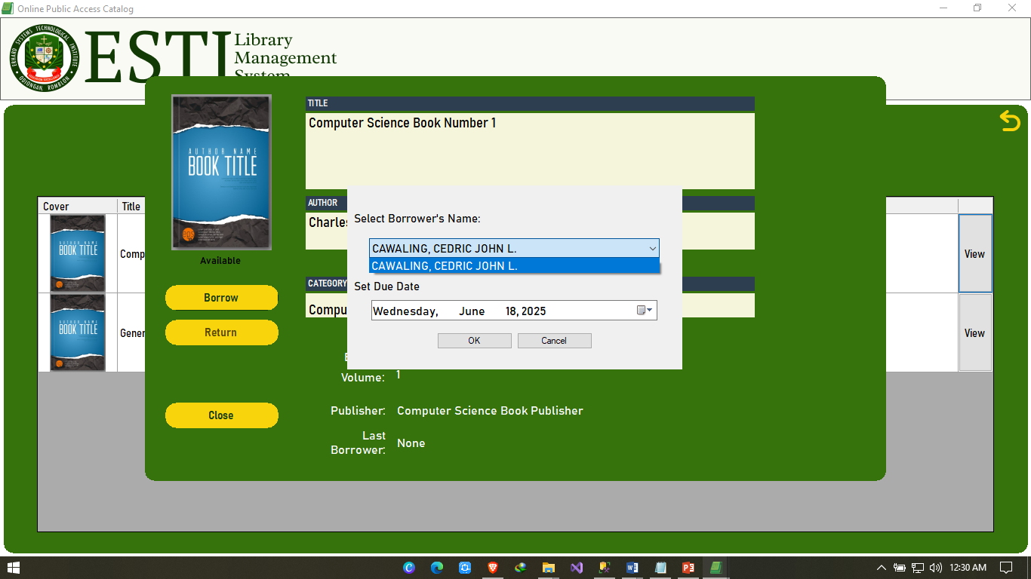

*Using Transactions Feature*

1.The admin can view the recent transaction using the View button and clicking return instantly changes the books’ status to “Returned”.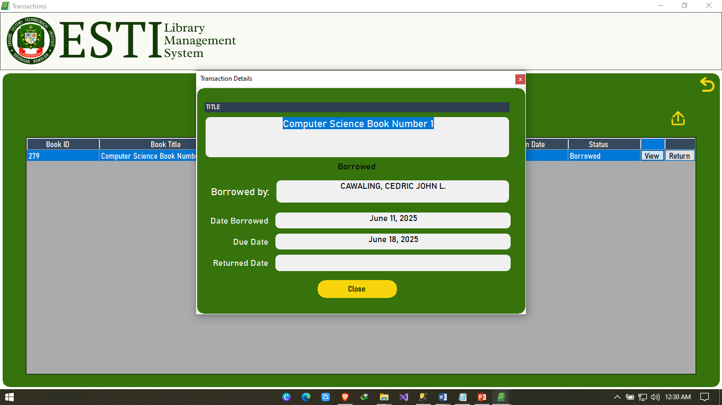

*Using Log Entry Feature*

1. Library Access Record saves the users data to track Library Entries, and also uses it for selecting borrower’s name in OPAC.

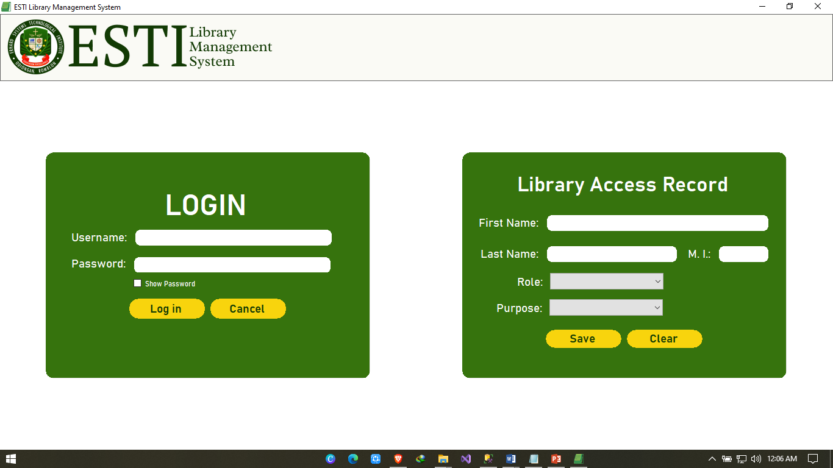

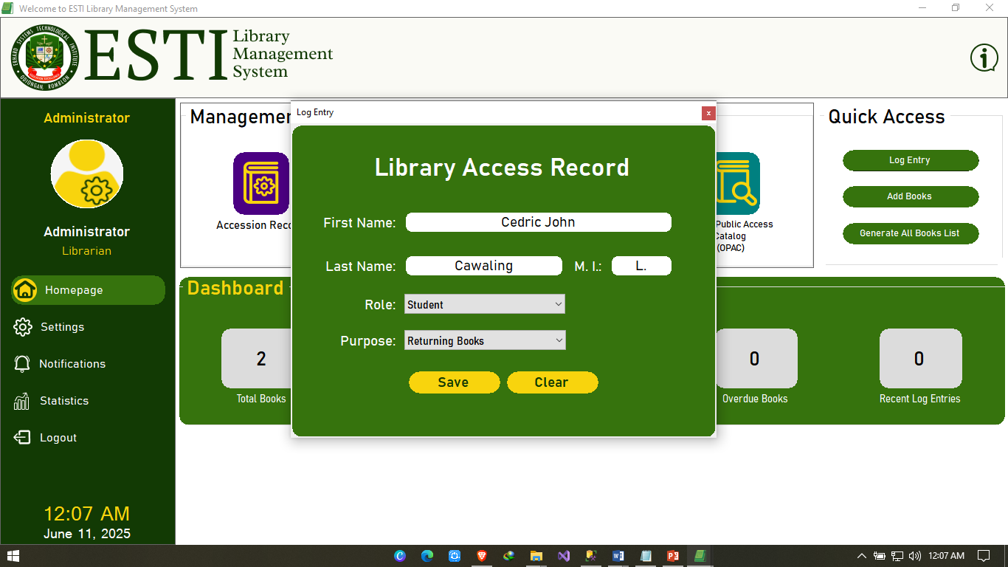

*Using Library Log Entries Feature*

1. This tracks user entry, role and activities. It can also generate reports for log entries and is used as data to display statistics

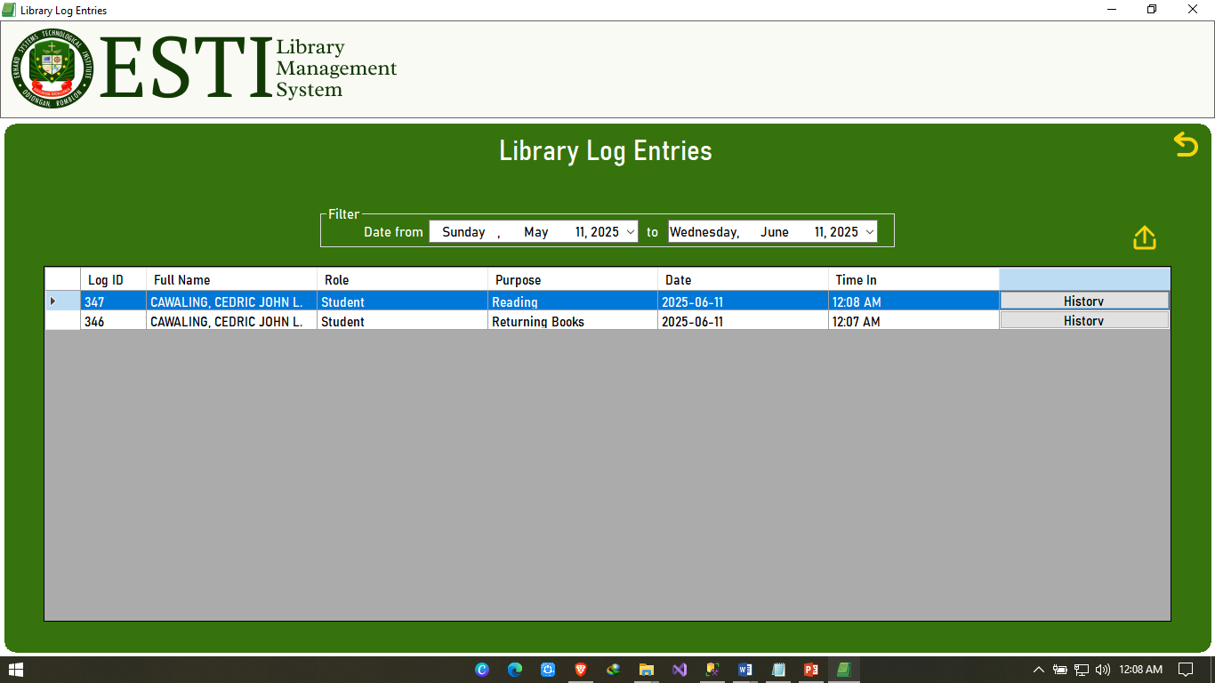

*Using Settings Features*

1. Settings includes adding another admin account, changing their own credentials such as full name, contact info, password and can add their own profile pictures.

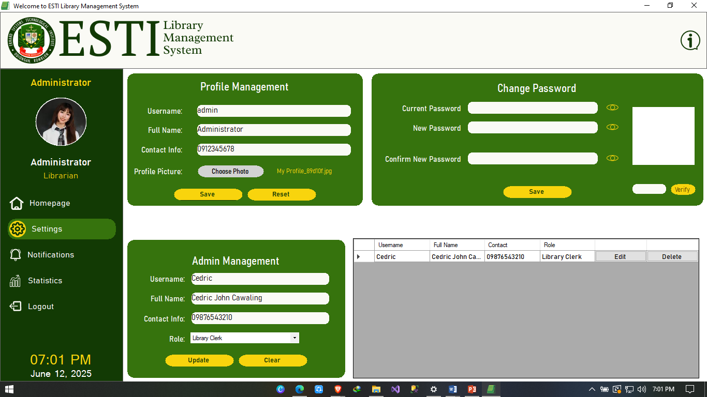

*Using Notification Feature*

1. Notification primarily displays overdue books. The admin can separate the alerts that are “read” and “unread” through a filter.

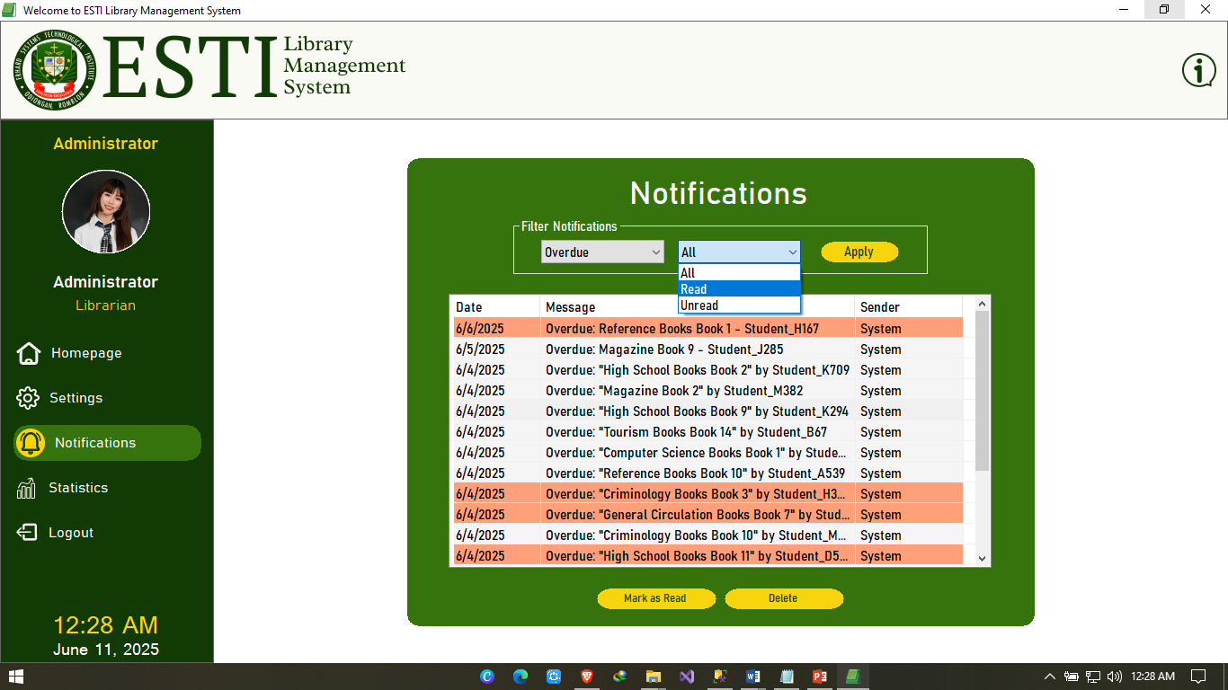

*Using Statistics Features*

1. Statistics mainly features the Generate reports for books by material type either for the checked ones or generating all. It also displays book count statistics.

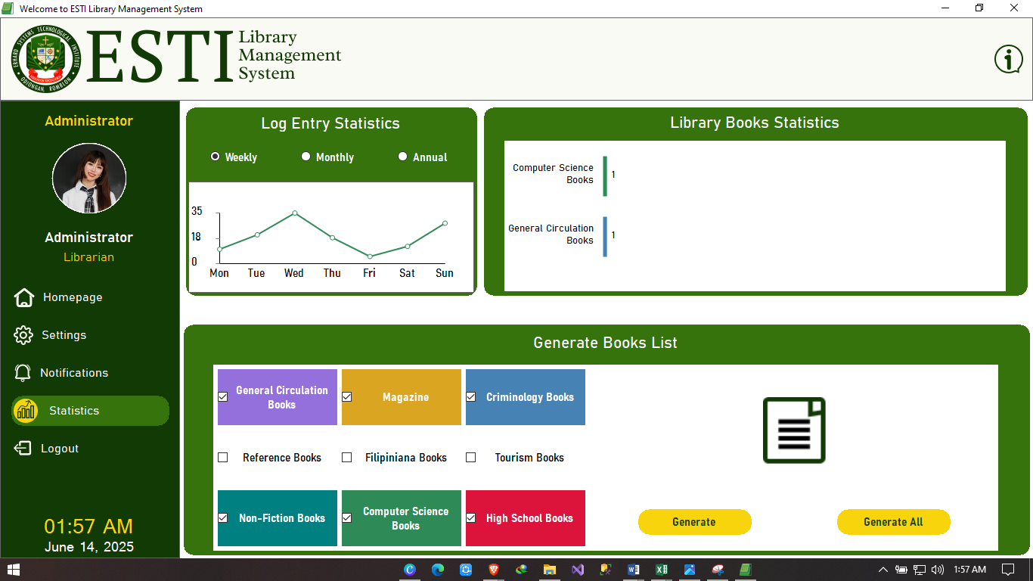

*Logging out*

1.Logging out requires a confirmation, clicking “Yes” will redirect to Login Form while clicking “No” lets the user remain in the Main Form.

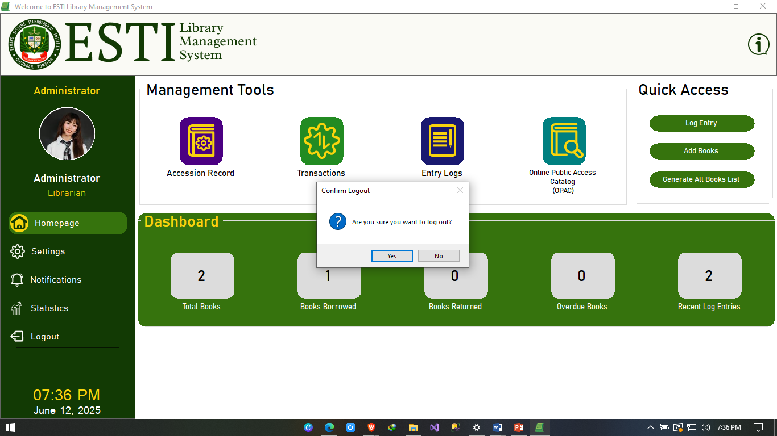

2. After confirming Log out, the system redirects to Login Form where the admin can log-in again using admin credentials, while users can still utilize the Library Access Record

**

**RESEARCHER’S PROFILE**

 **CEDRIC JOHN LUSTRIA CAWALING**

09493268020/cedricjohn.cawaling.7@gmail.com

**EDUCATION:**

BS Computer Science : Erhard System Technological Institute

Senior High School : Looc National High School – Senior High School

High School : Looc National High School

Elementary : Tabugon Elementary School

**TESDA NATIONAL CERTIFICATE**

**Computer Systems Servicing NC II**

April 2025 – April 2030

**WEBINARS/SEMINARS ATTENDED:**

**Cybersecurity**

Via Fb Live

June 27 2023

**Java Training**

Odiongan, Romblon

July 10-11 2023

**4Th MIMAROPA IT Congress**

Calapan, Oriental, Mindoro

Nov. 24 2023

**Cybersecurity 101 for Students**

Via Zoom

April 24, 2024

**DICT Python Essentials**

Odiongan, Romblon

October 26, 2024

**Computer Systems Servicing**

Montfort Academy

March 31 – April 2, 2025